Nanyang Technological University RobotX 2014
NTU Leviathan
Xie Zhen, Liu Jiaqi, Wu QiPing, Wang Han, Wang Yuanhan, Leong Wei Kang, Lim Chze Wee, Theo Meslin, Andrei Hutan, Ondrej Bruna

Abstract
Nowadays, the development of Unmanned Surface Vehicle (USV) has boomed around the world for both military use and research use, because USV has many advantages like cost-saving, time saving, labor saving, efficient, and its ability to free human from hazardous works. The objective of this research is to develop an autonomous vehicle for RobotX Challenge. To complete the 5 tasks in the RobotX Challenge, it is necessary to realize perception, guidance and control of USV. The hardware part includes processing unit, communication unit, detection unit, location and motion unit, power supply and safety measures. The data collected from the hardware equipment will be passed to the software layer to facilitate vision detection, path planning and motion control of the vehicle. The time strategy and the path planning strategy are implemented in the system in advance. The detailed hardware components, software architecture and game strategy are discussed in this paper.

- Introduction
Unmanned Surface Vehicle (USV) has been deployed intensively in recent years both in research use and in military use [1]. In research field, USV can be assigned to do ocean observation in replace of traditional methods, such as buoys, drifters and even human ship operation. Comparing with the traditional methods, the deployment of USV is low cost, efficient, easy to recover and energy saving. Also, the data collected is accurate, intensive and can cover many areas. As a consequence, USV may benefit oceanographic researchers by providing more comprehensive and overall information. When it comes to military service, USV can support Navy force to conduct coastal reconnaissance and surveillance missions or even tasks which may be hazardous for human or exceed human capabilities [2]. As a result, USV can achieve accuracy and robustness better than those from human operation.
A powerful USV may be able to execute multiple functions. The possible functions are: navigation, obstacle avoidance, target recognition, pattern recognition, color recognition and signal detection. To realize that, the USV should be equipped with sensors and actuators, including GPS, radar, camera, acoustics and compass, motors, propellers and controllers.
The design of our USV is for completing the 5 tasks in Robotx Challenge. After testing on the proposed algorithm and path planning method, behavior research and improvements will be made immediately. In the end, our USV will be able to complete the 5 tasks autonomously.
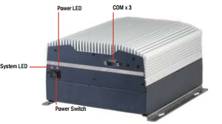
Figure 2.1.a: Embedded PC
This report will present the Unmanned Surface Vehicle that has been developed for the RobotX Challenge. To be more specific, the hardware components, software design, and the task strategy implemented will be discussed in the following sections.

Hardware components
2.1. Processing unit
a) Embedded PC (onboard PC)
Embedded PC (Figure 2.1.a, Table 2.1.a) is the main processing unit of the whole system. It is suitable for real-time control and monitoring because it processes fast. This embedded PC has many interfaces which allow easy connection with different components. Speaker, light emitter, motion control unit, cameras, LiDAR, GPS and compass are connected directly to this PC.
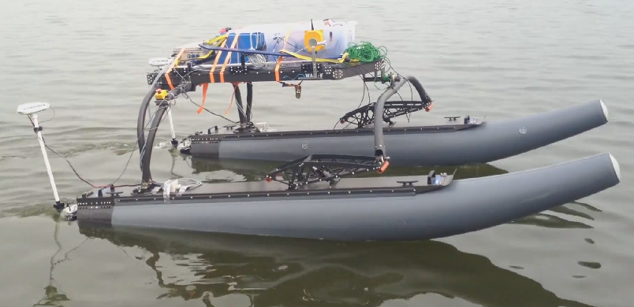
Figure 1.1: NTU Leviathan

Table 2.1.a: Specs of the Embedded PC.
Specifications | Figure
Models | AAEON embedded PC AEC-6877
RAM | 204-pin Dual-channel DDR3 1066 16G
Processor | Intel® Core™ Intel® i7-3610QE
Operating system | Linux Fedora
Hard drive | 500GBSolid State Hybrid hard drive
Chipset | Intel® QM77 Chipset
Display port | Three Independent Video Output for Display Port™ x 2 + VGA  or DVI with Ivy Bridge CPU
I/O Ports | USB 3.0 x 4, PCI x 2 or PCI-Express[x4] x , DB-9 x 1 for RS-232/422/485
Power Protection | Over-Voltage Protection  Low Voltage Protection  Short Circuit Protection  Surge Protection
Networking | LAN 10/100/1000Base-TX  Wireless Optional by Mini Card

b) Land PC
A laptop (Table 2.1.b) was used as the land PC. The GUI was implemented in it.
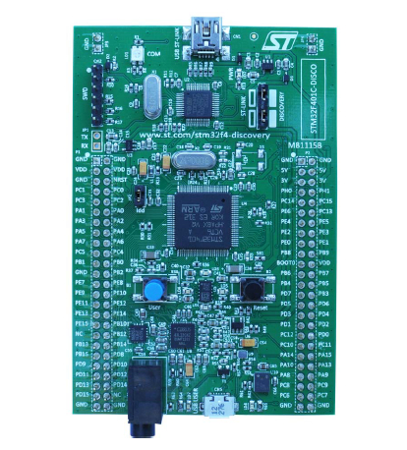Figure 2.1.c: Discovery board
Table 2.1.b: Specs of On land PC
Specifications | Figure
Models | Fujitsu Life Book T Series
RAM | 1GB
Processor | Intel core 2 Duo T6600
Operating system | Linux(GNOME)
Hard drive | 100GBSolid State Hybrid hard drive
Chipset | Mobile Intel® HM87 Express
Display | 13.3" QHD+(1024x768)
I/O Ports | 3 USB , 1 media card reader, 1 HDMI, 1min Display, 1 headset
Graphics Adapter | Intel GMA 4500MHD
Networking | modem, Ethernet, 802.11 a/b/g Wi-Fi, optional Bluetooth, optional WWAN

c) Microcontroller
The microcontroller consists of a discovery board, A/DC port and other electronic components. It has the following functions:
1. IMU unit on the discovery board(Figure 2.1.c, Table 2.1.c);
2. A/DC port to link to the Hydrophone;
3. Engine controller;

Table 2.1.c: Specs of Discovery Board
Specifications | figure
Models | STM32F401VCT6 microcontroller
Memory | 256 KB of Flash memory, 64 KB of RAM
Power | through USB bus or external 5V
Motion sensor | L3GD20, ST MEMS motion sensor, 3-axis  digital output gyroscope.
Acceleration &Magnetic sensor | LSM303DLHC,3D digital linear acceleration sensor and a 3D digital magnetic sensor
Audio sensor | MP45DT02,audio sensor,omnidirectional digital microphone.
speaker drive&LEDs | CS43L22, audio DAC with integrated class D  speaker driver. 8 LEDS

2.2. Communication unit

a) Antenna
Because the competition will be held outdoors in the Marina Bay Area Singapore, the antenna must have high gain to ensure the proper communication connection at all time and be weather-proof. Considering these 2 requirements, TP-Link TL-ANT2415 2.4G 15dBi Onmi-directional antenna was chosen.
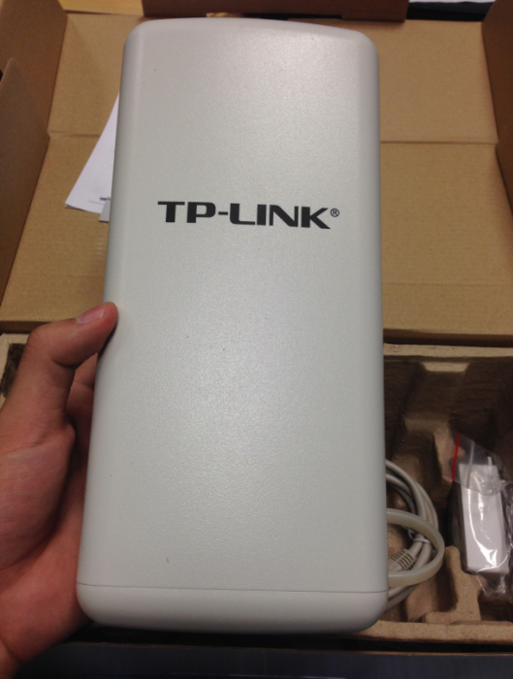Figure 2.2.b: Access Point
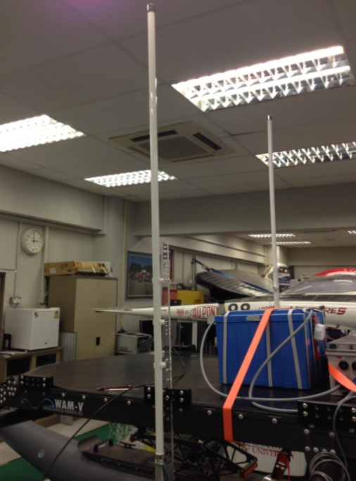
Figure 2.2.a: fixture of Antenna.
The plastic fixture prototype for the antenna is shown in the Figure 2.2.a. A metal fixture is in manufacturing, which will be used eventually.

b) Access point
In accordance with the antenna, an access point is used to provide a land control network for the manual control and monitor of the USV.
The communication connection of the USV need to be stable even in long distance. However, the normal router cannot reach so far in the open space, so the outdoor router was searched.
Finally the TP-LINK TL-WA7210N Outdoor Wireless N150 150 Mbps Access Point (Figure 2.2.b) was chosen, mainly because it can reach up to 15 km in the open space which meet the demand very nicely.
The characteristics of the access point is listed below:
-12dBi dual-polarized antenna,
-waterproof enclosure,
-4kv lightning protection,
-grounding terminal integrated,
-15 kV ESD protection.
-3 modes to choose: AP client Router (WISP Client), AP Router and AP operation mode,
-dedicated power amplifier,
-low noise amplifier which improves radio performance.

2.3. Detection unit

a) Hydrophone- Acoustic signal detection.
The Hydrophone (Figure 2.3.a-1) is used to detect the acoustic signal from the pinger and trace the location of the pinger.
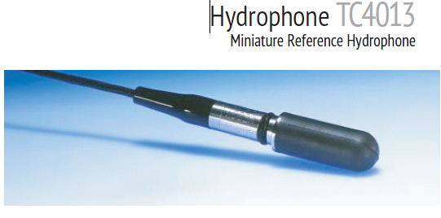
Figure 2.3.a-1: hydrophone.

The frequency and pulse rate of the pinger, which are found in the RobotX Challenge Website, are 25-40 kHz and 0.5-2Hz respectively. Referring to the Hydrophone’s specifications (Table 2.3.a), the signal frequencies of the pingers are within the usable frequency range, so it is sensitive and compact. In addition, this hydrophone is omni-directional.
As a result, this hydrophone is a suitable transducer for making absolute sound detections and measurements of the pingers in the competition.
Table 2.3.a: Specs of Hydrophone.
Specifications | Figure
Model No. | TC4013
Usable frequency range | 1Hz to 170KHz
Receiving sensitivity | -211dB±3dB
Transmitting sensitivity | 130dB±3dB
Horizontal Directivity Pattern | Omni directional ±2dB at 100kHz
Vertical Directivity Pattern | 270° ±3dB at 100kHz
Operation depth | 700m
Operation temperature | -2°C to +80°C
Weight | 75g
Cable length | 6m
Encapsulating material | Special formulated NBR
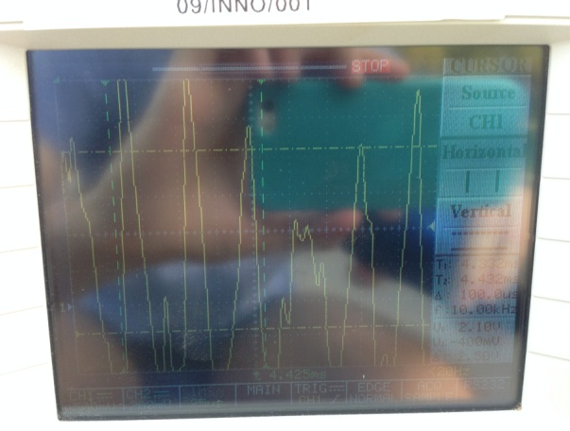
Figure 2.3.a-2: hydrophone testing results.
The hydrophone testing was conducted in the NTU swimming pool. As shown in the Figure 2.3.a-2, the result accuracy was satisfying.

b) Camera-vision signal detection
5 cameras (Figure 2.3.b, Table 2.3.b) are deployed in the USV to gather vision information.
Two cameras are in the front to form a stereo vision. One camera is mounted at each side of the USV. Another camera at the back is for assisting reverse movement.
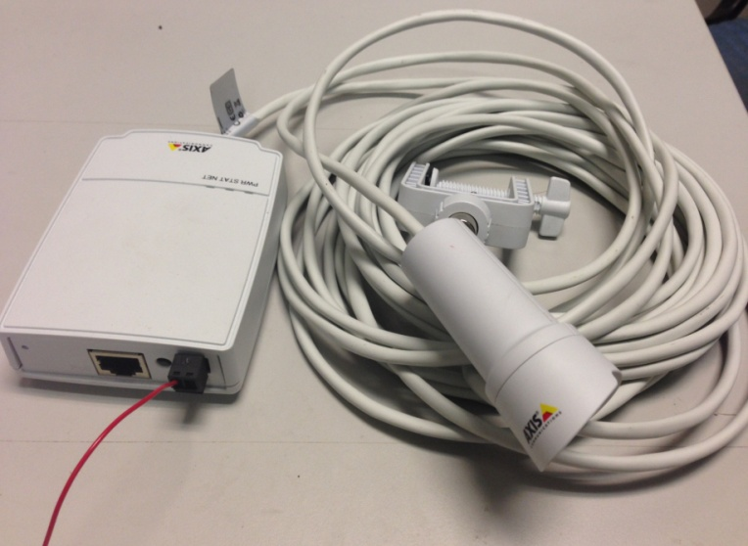
Figure 2.3.b: Water-proof camera.

Table 2.3.b: Specs of Camera
Specifications | Figure
Models | AXIS M2014-E: HDTV 720p, IP66-rated camera unit
Memory | 256 MB RAM, 128 MB Flash
Weight | Main unit: 109 g (0.24 lb.)  Camera unit: 270 g (0.6 lb.)
Power | Power over Ethernet IEEE 802.3af Class 2 (max. 6.49W) 8 – 28 V DC max 4.7 W
Operating Conditions | -20°to 50°
Connectors | RJ45 for 10BASE-T/100BASE-TX PoE RJ12 for the camera unit
Lens | 2.8 mm: 81° view*, F2.0, fixed iris, fixed focus *horizontal angle of view
Light  sensitivity | 1.0 - 10000 lux
Shutter time | 1/6 s to 1/24500 s
Resolutions | 1280x720 to 320x180
Frame rate H.264&JPEG | 25 fps with 50 Hz  30 fps with 60 Hz
Video compression | H.264 (MPEG-4 Part 10/AVC) Motion JPEG
Image sensor | 1/4” progressive scan RGB CMOS

c) Leddar - obstacle detection
A Leddar (Figure 2.3.c) works together with camera to detect the nearby obstacles and gates. The range(Table 2.3.c), 50m, is good enough for the task course. It is mounted at the height of 0.5 meters to ensure the effective laser scan of the obstacle.
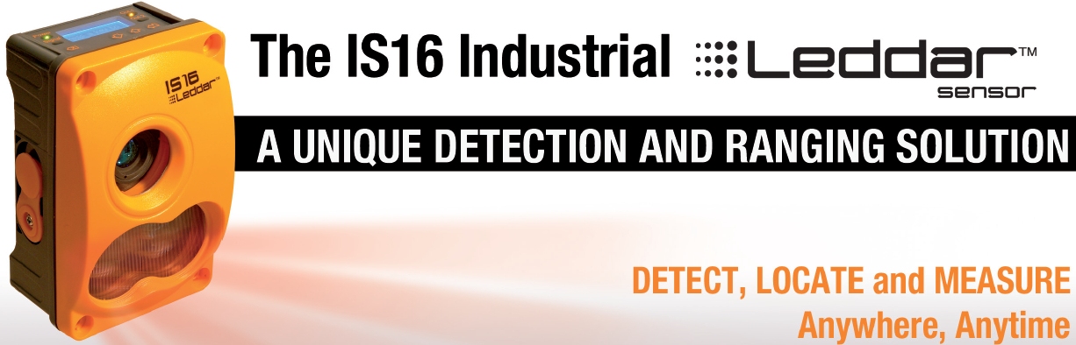
Figure 2.3.c: Leddar.

Table 2.3.c: Specs of Leddar.
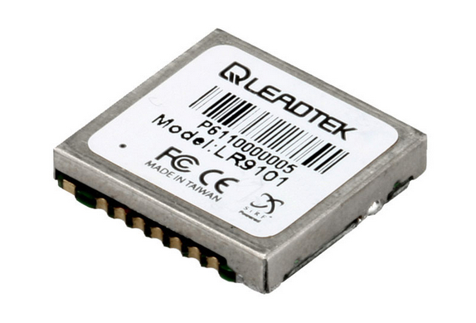
Figure 2.4.a: the GPS.
Specifications | Figure
Data refresh rate | up to 50 Hz
Detection range | 0 to 50 meters (165 ft.)
Accuracy | 5cm
Operating  temperature range | -40°C to +50°C
Acquisition | 16 segments simultaneously
Distance resolution | 10 mm
Ingress protection | IP67
Power consumption | 5.6 W
Beam options | 45°
Wavelength | 940 nm
Power supply | 12 to 30 VDC
Interfaces | USB, RS-485
Wavelength | 940 nm
Distance resolution | 10 mm
Dimensions | 136 mm x 86 mm x 70 mm
Weight | 430 g
Discrete output | 2 x PNP/NPN
Analogue output | 4-20 mA , 0-10 V
Connector | M12

2.4. Location and motion unit

a) GPS
Since position information is required for completing all the tasks, GPS accuracy is vital. The GPS (Figure 2.4.a, Table 2.4.a) provides feedback about the current location coordinates to the control loop. Moreover, from the GPS trajectory, velocity and acceleration can be estimated.
Table 2.4.a: Specs of the GPS.
Specifications | Figure
frequency | L1, 1575.42 MHz
Dynamic Conditions | MAX: 18,000m; 515m/s; 4g;
Sensitivity | -163dB
Operating temperature range | -40°C to + 85°C
Position Velocity | < 2.5 meters 0.01 meters/second
Channels | 8
Protocol messages | NMEA0183@4800bps
Power &Power | 1.71 ~ 1.89 VDC input,
consumption | 41mA
Datum | WGS-84
Reacquisition | 0.1 sec., average

b) Compass
Compass (Figure 2.4.b, Table 2.4.b) gives the heading angle, pitch angle, and roll angle, magnetic magnitude and acceleration in X, Y, Z directions. It provides current position information of the vehicle.
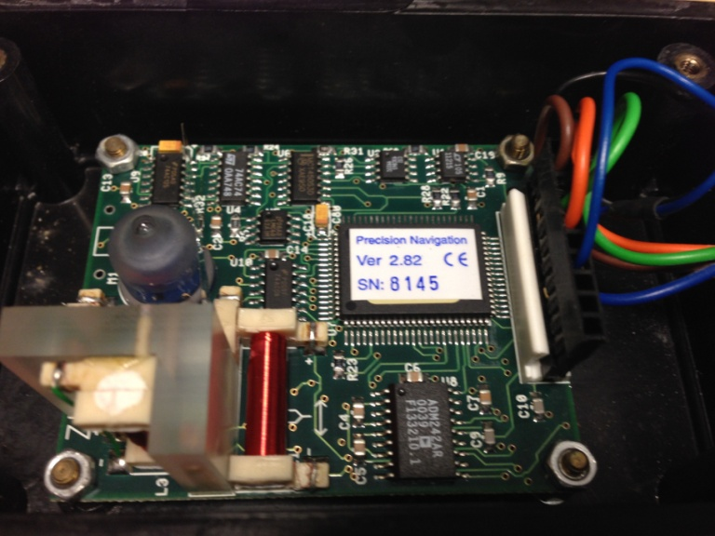
Figure 2.4.b: customized compass.
Table 2.4.b: Specs of Compass.
Specifications | Figure
Compass heading accuracy | 0.8°
compass heading resolution | 0.1°
High repeatability | 0.1°
Wide tilt range | ±50°C
Multiple measurement modes | compass  heading, magnetic field and 2‐axis tilt
Operating  temperature range | -40°C to +50°C
Power | <20 mA typical current draw
Connection | compatible digital interface
Backwards compatible footprint | TCM2  hole spacing

c) Inertial Measurement Unit (IMU)
The IMU is embedded on the discovery board, reporting the vehicle’s velocity, orientation and gravitational forces. The data from IMU assists the steering of the vehicle.

d) Engine controller
The engine is controlled by a discovery board and a digital potentiometer(Figure 2.4.d).
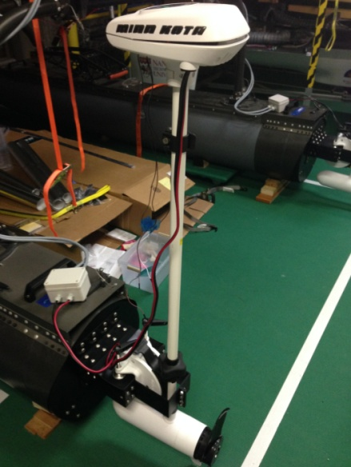
Figure 2.4.e: mounted Engine.
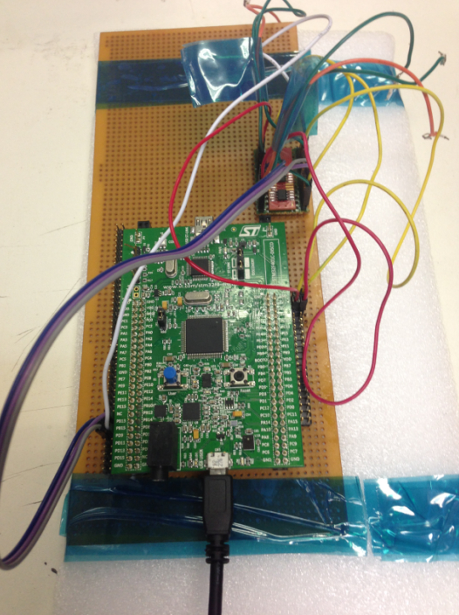
Figure 2.4.d: Engine controller.
The digital potentiometer has 256 steps, so the forward of the vehicle can be controlled by 128 steps and the backwards of the vehicle by the other 128 steps. Changing of resistance will result in changing of current, and the output of the propeller will change accordingly.

e) Propeller
Propellers are not only used to push the vehicle ahead, but also help the vehicle change headings whenever there is a speed difference between the left and right propeller.
When the propellers were mounted on the vehicle (Figure 2.4.e, Table 2.4.e), experiments was conducted to create a lookup table for the steering. The table was the basis for the motion control. From the table, the exact rotation speed of the two thrusters can be determined given the vehicle steering angle.

Table 2.4.e: Specs of Propeller.
Specifications | Figure
Models | RIPTIDE SALTWATER  TRANSOM-MOUNT MOTORS RT80T
Mount | One Hand Stow
Control | Tilt/Extend T一ller
Max thrust | 80lbs
Max Amp Draw | 56A
Volts | 24V
Speed FWD/REV | Variable
Shaft Length | 42’
Composite shaft | Yes
Max boat length | 25’
Digital maximizer | Yes
Prop | Weedless Wedge 2

2.5. Power supply and safety

a) Battery type
On one hand, the battery should be light weighted considering the load limit of the vehicle is about 225KG. On the other hand, the battery should provide adequate current for the propellers.
3 types of batteries were considered. However, the light-weighted lithium battery cannot give the current for starting the propellers, while car battery is much heavier even though it gives the maximum current for the propellers.
Hence, Iron Lithium Phosphate Battery (Figure 2.5.a) is used, because it is light-weighted and fulfills the current requirement for the propellers.
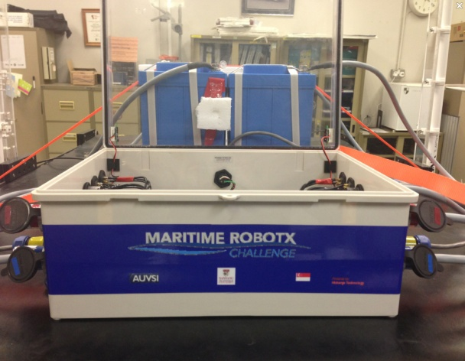
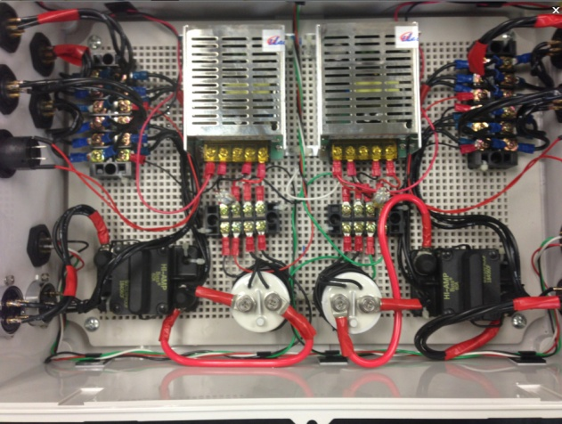
Figure 2.5.b: Battery control box.
The final battery design is to use two 24V, 70A.h batteries in parallel to sustain 1 propeller. In total, four batteries of 24V 70A.h will be fixed on the top tray of the vehicle. Each battery has 18KG weight. The battery uses an ABS housing IP65 to be splash-proof.
The charger has 25A charging current, which means that within three hours one battery can be fully charged. The maximum current for the battery is 60A.
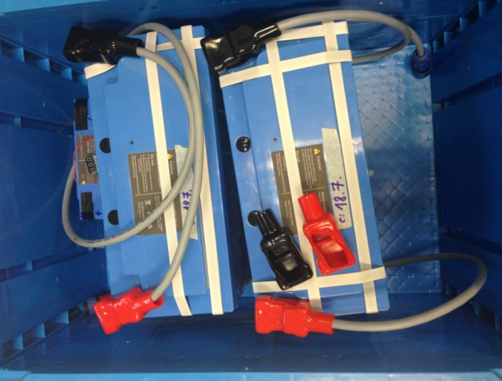
Figure 2.5.a: 24V, 70Ah Battery

b) Battery control box
The Battery box (Figure 2.5.b) is designed for the safety control of the battery. In order to ensure the function and safety of the electronics under bad weather condition, all the cables are sealed and the connectors are IP65 splash-proof. Besides this, a voltage indicator is fixed on the side of the transparent cover of the battery control box, and two LED lights will be on when the circuit is closed.

c) Engine Junction Box
The Engine junction box (Figure 2.5.c) is mounted on the water ski of the vehicle, and served as a link between the engine power line and the battery control box. It is IP65 splash-proof.
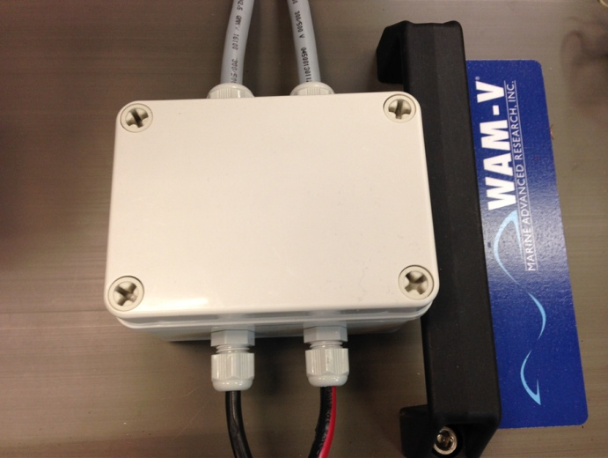
Figure 2.5.c: Engine junction box.

d) Emergency Stop
Two emergency stop bottons (Figure 2.5.d) are mounted at both sides of the vehicle. They can be reached by kayaks easily if the boat needs to be stopped. When either emergency stop is pressed, the two engines will shut down immediately. In addition to that, a wireless emergency stop can be triggered remotely.
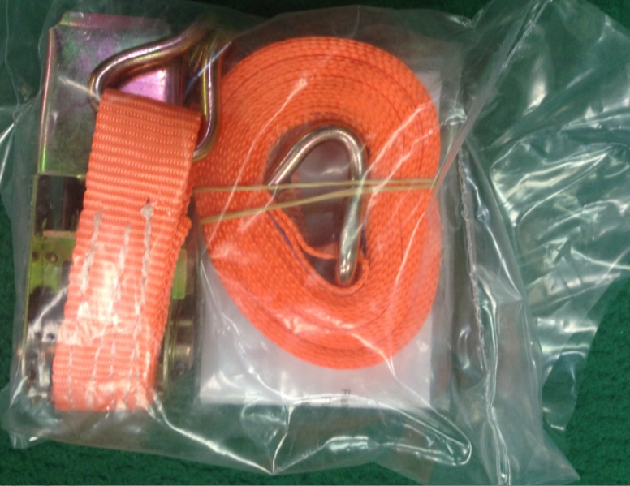
Figure 2.5.e-2:Marine Tie Down Strap.
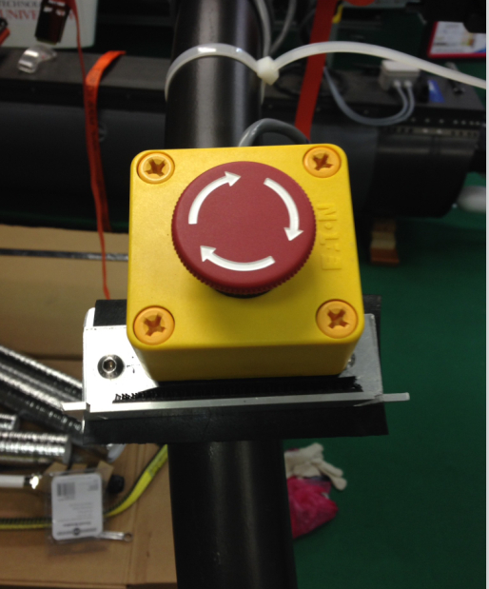
Figure 2.5.d: Emergency stop button.

e) Mechanical Fixture
The original prototype of the boat fixture is shown in the Figure 2.5.e-1 below.
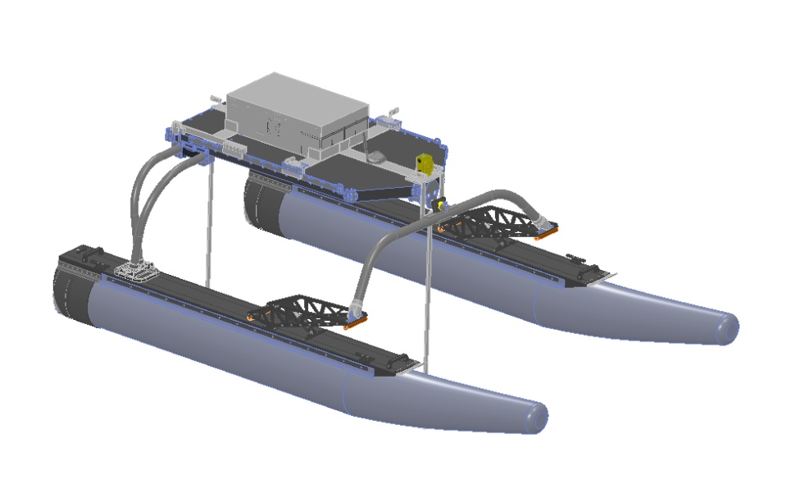
Figure 2.5.e-1: Vehicle Mechanical Fixture
To make the fixture more practical, simple, light weighted, the marine tie down straps (Figure 2.5.e-2) was introduced in to hold the battery and the control box even firmly on the tray(Figure 2.5.e-3).

Software part
Generally, software part contains graphic user interface (GUI), communication protocol, vision detection, path planning and motion control.
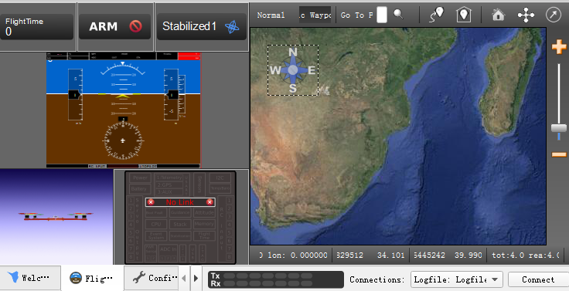
Figure 3.1-1: Open Pilot Ground Control Station.

Main work for the software part is developing algorithm, building software libraries and setting up specifications for each software modules, to ensure the respective hardware can function properly.
Till now, the visual studio codes for individual hardware component module are working properly. Data can be logged into files. Besides this, the communication between components and PC is working well. Also the communication between on land PC and onboard PC has been set up. All the codes have been compiled into classes which make it easier to integrate and implement. The design of path control loop is still in process.

1) GUI design
GUI design is based on the open source- Open Pilot Ground Control Station (GCS). The Open Pilot GCS (Figure 3.1-1) is very efficient and interactive with users. All the functions are shown in tabs, which allows user to control the vehicle, set parameter and keep maintenance easily.
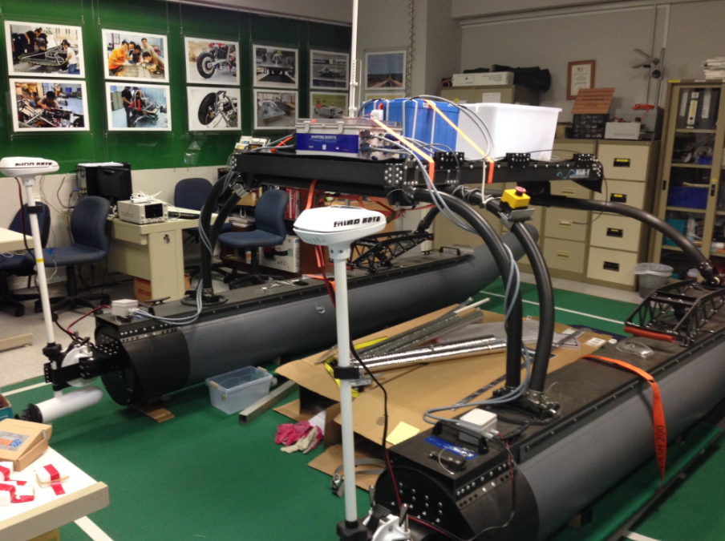
Figure 2.5.e-3: Final Fixture.
The Open Pilot GCS is originally designed for UAV. It is similar to the control of Unmanned Surface Vehicle. Functions included are: GPS mapping, vehicle heading, pitch and roll angle, speed, acceleration reporting, motor controlling, camera data streaming, etc.
Simple modification has been made to the Open Pilot GCS, so that it can fit into the operation, display, maintenance of USV.
The GUI has two parts: Display and Operation & Maintenance. The user can select which part to show by clicking the button (Figure 3.1-2).
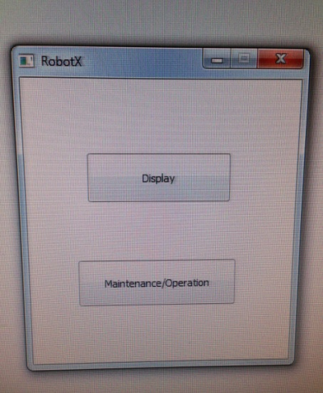
Figure 3.1-2: GUI has 2 parts.
On the Display page (Figure 3.1-3), users can see the data coming from all the sensors including GPS, Compass, range Finder, camera, hydrophone and propeller.
On the Operation & Maintenance page (Figure 3.1-4), users can select the output percentage for the engine to manually control the USV. Users can also switch to unmanned mode to let the USV conduct the tasks. An Emergency Stop button together with a wireless E-stop switch is set up for the safety purpose.
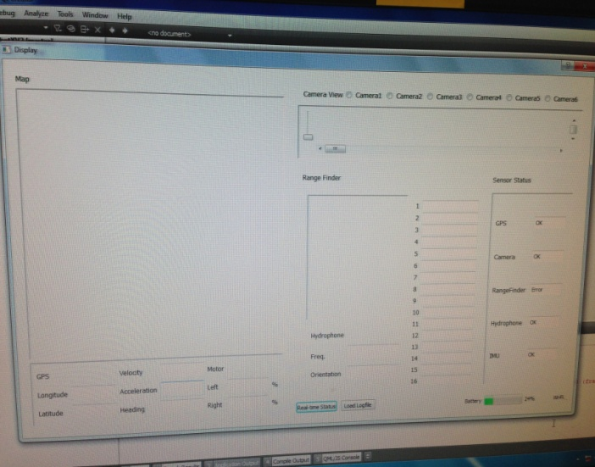
Figure 3.1-3: Display page.
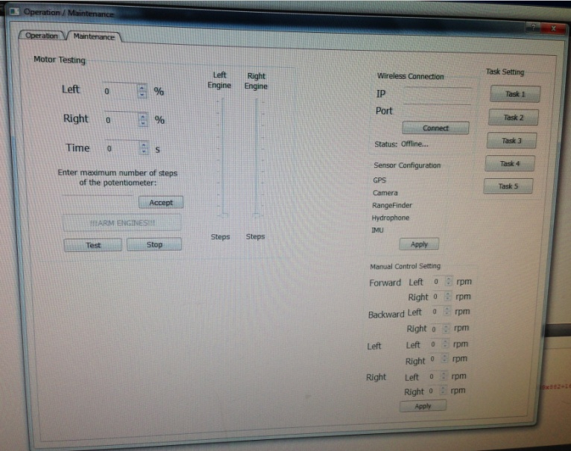
Figure 3.1-4: operation and maintenance page.

2) Communication protocol
Two communication lines are available on our vehicle: the communication between the control station and the onboard pc, and the transmitting heart beat between the judge and the onboard PC.
For the tele-operation and boat surveillance, we can use GUI, android app and radio to control the vehicle. TP-Link access point was used to build a network to cover the competition area. The TP-Link outdoor wireless access point can reach maximum 15km, so it should be good enough for the vehicle to communicate with the on-land control station GUI or hand phone. There is also a router on board the vehicle which provides wifi network around the boat, so redundant network can be used. Also in case the wifi is not recommended. We also have radio control available so that there is no wifi network interference with the judge network.
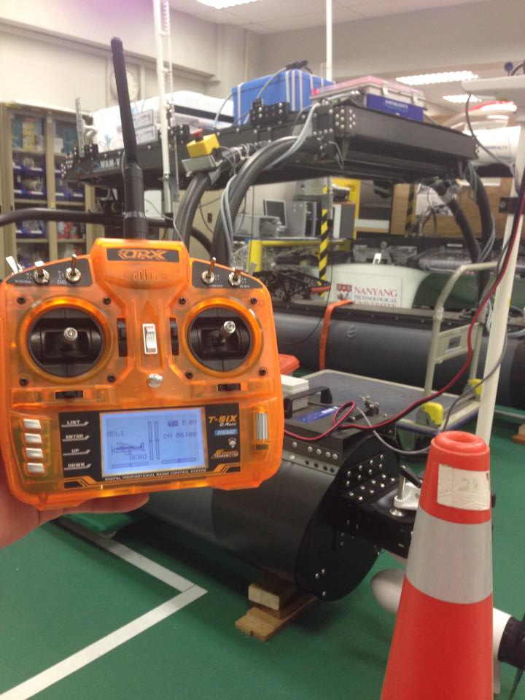
Figure 3.2: Radio control
As required from the judges, the vehicle is able to connect to an 802.11g wireless (Wi-Fi) network. During the competition, an IP address will be required from a DHCP server. Once connected, a TCP connection will be established to a server to pass an address and port number assigned for the competing course. A different NMEA sentence will be defined for each challenge requiring communication between a vehicle and a judge.
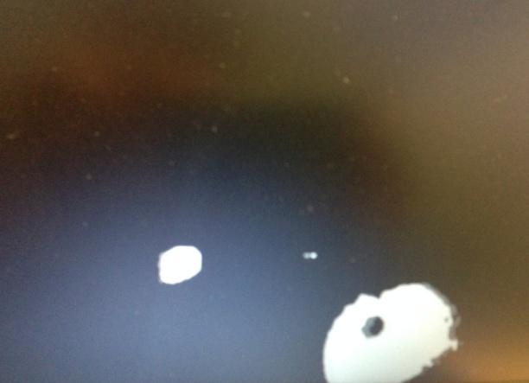
Figure 3.3-3: threshold image

3) Vision
A blob library is utilized to help recognize the blobs in the image. An original image, a threshold image and the control panel will be shown when running the program (Figure 3.3-1).
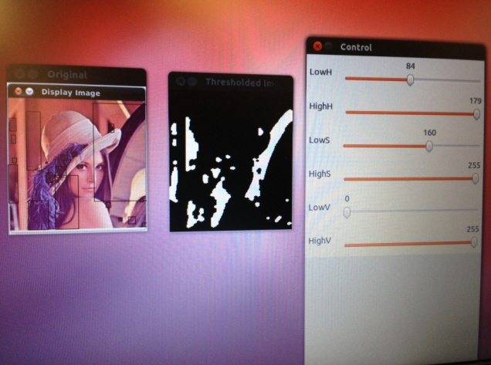
Figure 3.3-1: Blob recognition.

By moving the bar of the control panel (Figure 3.3-2), the threshold value can be changed to produce threshold images with different sensitivity. In each threshold image, the obstacles are in white blob, while all the other objects are in dark background (Figure 3.3-3). In this way, the floating buoy can be distinguished from the surrounding and thus located.
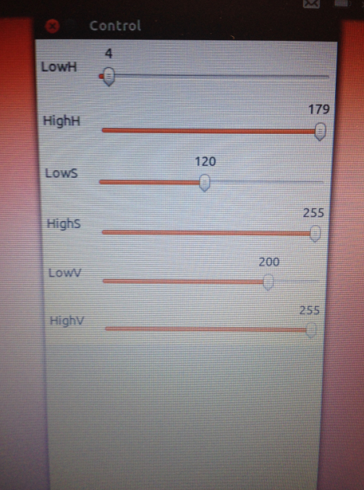
Figure 3.3-2: control panel bar
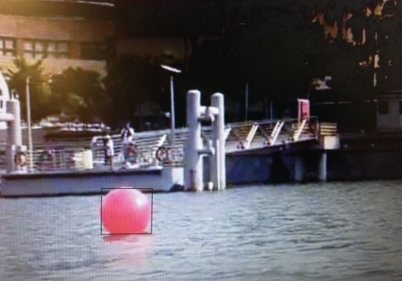
Figure 3.3-4: Obstacle detection
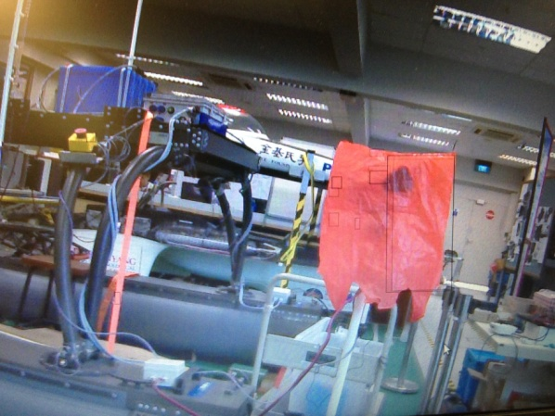
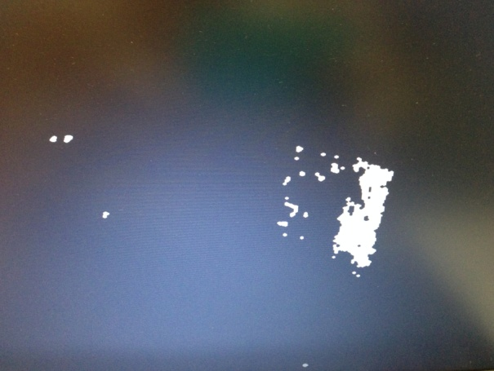
Figure 3.3-5: live blob detection and the threshold image.
The algorithm we developed is able to detect the round red obstacle. The light sequence of the light buoy, shapes and gates can also be recognized.
To test the obstacle detection function, the video provided by the organizer which is similar to the competition environment were used. The result was positive: the red buoy in the video was recognized successfully (Figure 3.3-4).
Another test was run using the IP camera live video stream. The IP address for the camera was set up and passed to PC, and then the video taken was streamed to the PC. As shown in Figure 3.3-5, it can detect the red plastic bag easily and accurately.

3) Path planning
Accurate information about the surrounding environment is essential for making good path planning. Therefore, the data from all sensors must be integrated properly.
Briefly, the path generation process begins by randomly creating a predetermined number of paths. The paths are created by joining straight line and constant radius segments together end to end. Once these are created the evolution process can begin.
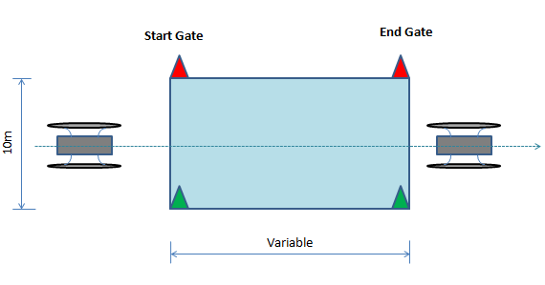
Figure 4.2.a-1: task 1 arrangement.
The detailed path planning is discussed in the path strategy section.

4) Motion control
By processing data from location and motion units, the engine controller that presented in section 2.4.d will calculate and give an output to propellers.

- Task Strategy
  - Time strategy
To make USV accomplish a set of ordered and specific tasks, a mission control program is created. The program is a state machine. On one hand, it monitors the status of each ongoing task; on the other hand, it has timeouts to abort a task if failed to complete within a time limit. Therefore, by allocating a measured amount of time to each task, it prevents one task from consuming the entire run time. Debugging and monitoring is greatly simplified by utilizing the state machine.

4.2. Path strategy

a) Task 1: Basic navigation and control
When the GPS coordinates of the entrance and ending gate (Figure 4.2.a-1) are passed to the system, the system will calculate the heading and way points for the boat to follow. At the same time, vision and LiDAR assist in recognizing the gate for entering and exiting the course way.
The real time GPS and heading will be feedback to the system to calculate the difference between current and desired way points. Afterwards, action will be taken to minimize the difference so that the vehicle can follow the desired path closely. Until the vehicle exits the gate, the task is considered completed (Figure4.2.a-2).
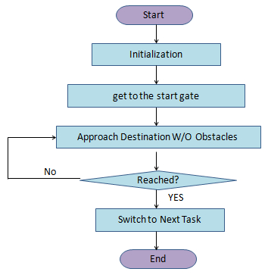
Figure4.2.a-2: task 1 control diagram

b) Task 2: Underwater search and report.
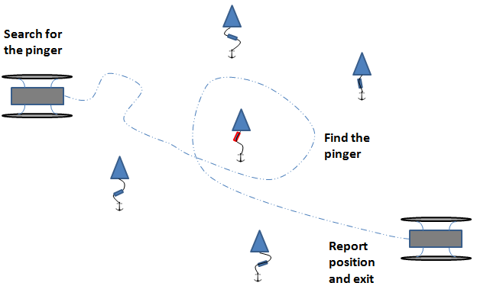
Figure 4.2.b: Task 2- Underwater search and report.
To find the proximate location of the pinger, hydrophone will be deployed (Figure 4.2.b). Besides, because every pinger is attached to a buoy, vision guide from camera and LiDAR is working together with hydrophone to accelerate the search process.
When the vehicle stops at the correct buoy with activated pinger, GPS will record the GPS location coordinates and hydrophone will confirm the pinger frequency to report to the judges.

c) Task 3: Symbol identification and docking.
After the second challenge, the boat needs to go to the proximate GPS location of the docking platform which will be published before the event day. There will a loop which compares the current location to the goal location. Only when the difference is small enough, the vehicle will slowly move around to find the docking platform with the assistance from cameras and LiDAR.
When the docking platform is found, vision methods will be used to find the docking bay with the correct symbol on the competition day. After finding the right docking symbol, the vehicle will approach to the docking bay very slowly and stop before hitting the wall. After stopping there for 30 seconds, the vehicle will start again and move backwards in order to exit the docking bay.

d) Task 4: Observation and report
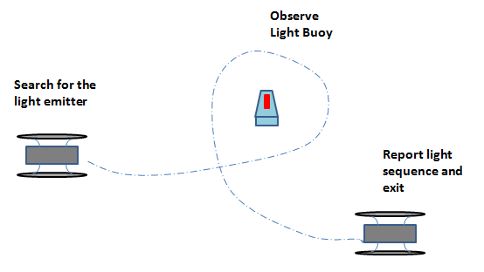
Figure 4.2.d: Task 4 layout
After vehicle reaches the Task 4 area that marked by four GPS points (Figure 4.2.d), the vehicle will begin to circle around and search for the light sequence buoy. The vehicle needs to use cameras and LiDAR to find the light buoy on the water surface, as the GPS coordinates of the light buoy is not available.
Then the vehicle will approach the light buoy and stop in front of one LED bar. Then, the cameras will take at least a 6-second video of the light bar, so that it can capture a whole light sequence period. Then the system can analyze the video, distinguish the color and calculate the light emitting time. In the end, the communication module will send the results to the judge counter using specific protocols.
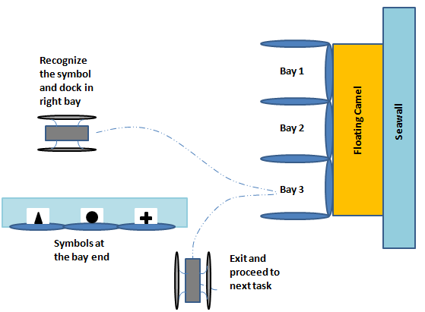
Figure 4.2.c: Task 3 layout

e) Task 5: Detection and obstacle avoidance
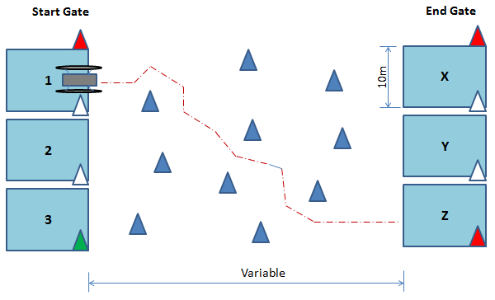
Figure 4.2.e-1: Task 5 layout.
In ocean environments, ship navigation must give great consideration to the maneuverability of the vehicle, which is usually a highly under-actuated system. Numerous studies about ocean navigation have been performed, but most have been focused on collision avoidance rather than the path planning problem. More advanced approaches to path planning such as genetic algorithms or fuzzy set theory have recently been reported by Szlapczynski and Patnaik et al. However, they have not given much consideration to the actual turning capability of USVs, which is critical not only for path planning but also for maneuvering of the vehicle as well. Most underwater vehicles are often assumed to be highly maneuverable, so that there are no explicit constraints on their turning ability, but this is not true for most surface vehicles.
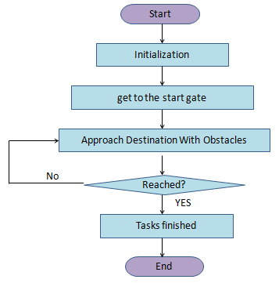
Figure 4.2.e-2: Task 5 control flow chart.

First, the safety distance of the obstacle buoy shall be known. In our case, the centre of the boat should be at least 3m away from the polymer buoys in order to avoid it.
Secondly, a combination of a LiDAR and machine-vision cameras are used. It is because LiDAR can provide accurate detection and locations for buoys, while the camera can provide identification of the color. By modeling the spatial projection that is inherent in the camera, the LiDAR points are able to be projected onto the images. By matching detections from the LiDAR with detections from the camera, positions and colors can be associated.
Only LiDAR is needed to avoid blue obstacle. But for entering and exiting the correct gate, both LiDAR and cameras will be used to complete the action.
Before starting Task 5, the entering and exiting gate location will be passed to the vehicle. A set of way points will be generated along the straight line that connects the start gate and end gate. The vehicle will follow the way points until LiDAR detects an obstacle buoy (Figure 4.2.e-1 ). Then the onboard PC will send command to the engine so that the left and right engine will spin at different speed. As a result, the vehicle will change its direction (Figure 4.2.e-2 ). When the distance between the vehicle and the buoy is larger than the safety distance, the two engines will change speed again, and the vehicle will approach its desired trajectory until it reaches the end gate (Figure 4.2.e-3).
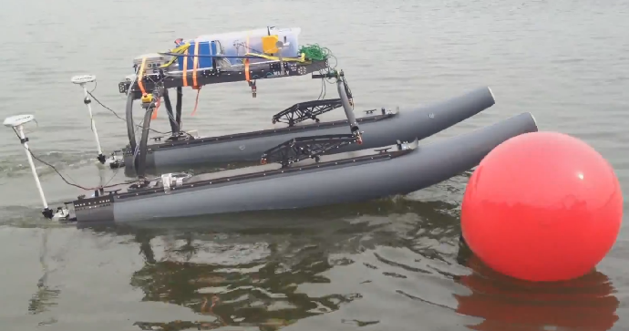
Figure 4.2.e-2: Obstacle Avoidance Test

- Conclusion
This paper presents an Unmanned Surface Vehicle especially designed for the RobotX Challenge. In the other word, this USV is built to complete 5 tasks, namely: navigation and control, underwater search and report, symbol identification and docking, observation and report, and obstacle detection and avoidance.
To fulfill the requirement, in terms of the hardware, this USV is equipped with processing unit, communication unit, detection unit, location and motion unit, power supply and safety measures. As for the software layer, graphical user interface, communication channels, vision detection algorithm, path planning algorithm and engine controllers are integrated into the system. It allows the vehicle to have a “brain”, so the vehicle can react to the dynamic environment and make reasonable decisions. Other than that, the game strategy is developed and implemented according to different tasks.
In the near future, testings will be conducted to evaluate the performance of the vehicle. Adjustments and tunings will be done to tackle down the existing problem.

References
- Massimo Caccia, Marco Bibuli, Riccardo Bono “Basic navigation, guidance and control of an Unmanned Surface Vehicle” Autonomous Robots, Springer Us, November 1994, vol 25, pp. 349-365.
- W Naeem, T Xu, “The design of a navigation, guidance and control system for an unmanned surface vehicle for environment monitoring”, Proceedings of the Institution of Mechanical Engineers, Part M: Journal of Engineering from the Maritime Environment, June 1, 2008, vol 222, pp. 67-79.

