Autonomous Surface Vehicle : MACS

Team MoMo
Seoul National University

Joohyun Woo, Induk Seo, Jooho Lee, Jongyeol Park, Ahmin Park, Midan Kim, Yoowon Jung, Jungho Park, Rokha You, Hujae Choi, Nakwan Kim

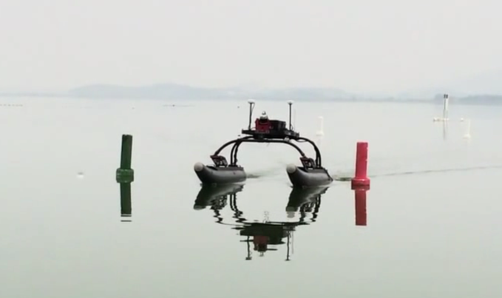
Abstract
This journal describes design of the Autonomous Surface Vehicle of Seoul national University, MACS. MACS is built to participate in the International Autonomous surface vehicle contest, Maritime Robot X, hosted by AUVSI and ONR. Technical approaches of various aspects of MACS are illustrated in this journal including propulsion system, environment sensing, docking and underwater search.
Figure 1 Autonomous Surface Vehicle MACS

Introduction
MACS is an autonomous surface vehicle designed by ASV club MoMo, at the Seoul National University. Just like other participants in Maritime Robot X competition, MACS is built on WAM-V (Wave Adaptive Modular Vessel) platform. Propulsion system, Sensor interface and a number of algorithms were designed by MoMo for successful operation of MACS in Maritime RobotX competition.

Position and Attitude of MACS is measured by GPS and INS sensors. In addition, MACS senses nearby environment by using lidar sensors, camera and passive sonar. By synthesizing informations from each sensors, MACS makes decisions about her future motion. Our goal is to make a suitable integration of informations from different sensors and structured environment, in order to make a safe and successful operation of MACS in the competition environment.
System Architecture
Figure 2 System Architecture of MACS
System architecture of MACS is composed of 6 interfaces. Sensor interface deals with low-level sensing of ASV’s current states and nearby environment. While sensor interfaces measures data, cognition interface processes this data into useful information. For example, localization interface collects data from GPS, GPS compass and INS, integrate them into one 6 DOF navigation solution in user defined coordinate. Information processed by cognition interface passes through Path planning interface. Path planning interface synthesizes information from various cognition interfaces, making desirable path to track. Once path is generated by path planner, it is modified by local path planner. If there is obstacle around current location of ASV, Local path planner modify current path in the way of avoiding it. Vehicle Interface includes PID controller for ASV motion control. Controller calculates desirable control input for tracking current path generated by path planning interface. If control mode is set as manual mode, vehicle interface reads RF signal generated by remote controller, generate corresponding control input to both thrusters mounted on ASV.

Hardware Specification
In order to perform given mission successfully with full degree of autonomy, MACS is composed of a number of sensors and embedded computers. Detailed information of hardware specification is given in table 1.
Table 1 Hardware devices used in MACS
Device | Model | Spec | Quantity
Lidar | SICK  LMS511 | 80m,  190 deg | 1
Camera | Pointgrey  BlackFly |  | 1
GPS | Novatel Smart 6 | L1/L2 | 2
INS | MicroInfinity  MI-A3370 |  | 1
Thruster | MinnKota  RT160 | 160 pound | 2
There are two computers in the system of MACS. First one deals with navigation and control. In order to guarantee deterministic loop, real-time embedded computer was used. Second computer deals with sensing of nearby environment. By using computer vision sensor and lidar, MACS detects obstacles and nearby environments.
Propulsion System
Because shape of WAM-V platform is catamaran shape, and to keep the simplicity of propulsion system, MACS uses two thrusters for steering control instead of using rudders. By controlling RPM of each thruster separately, yaw moment for steering control can be generated. RPM command of each thruster is calculated according to following equation.
$${RPM}_{Left } :u_{1}×S_{speed}+u_{2}×S_{steer}$$
$${RPM}_{Right} :u_{1}×S_{speed}-u_{2}×S_{steer}$$
$u_{1}$ : Control input for speed
$u_{2}$ : Control input for steering
$S_{speed}$ : Scale factor for speed control
$S_{steer}$ : Scale factor for steering control
RPM control command for both thrusters can be calculate as linear combination of weighted control input. Scale factor value is determined by experiment. Since RPM commands of both speed and steering control are linearly superposed, effect of one may be canceled out by another. To avoid this situation, speed controller of MACS is switched off and $u_{1}$ becomes constant value when absolute value of $u_{2}$ exceed certain value. This is because accuracy of heading control is far more critical for successful operation for each mission.

Environment sensing
- Lidar Nodding System
To sense obstacles, MACS uses a two -Dimension Lidar sensor (SICK LMS-511). 2D lidar only detects obstacles in front of the sensor. Therefore, if 2D lidar is fixed to ASV with certain tilting angle, there must be blind region. To overcome this limitation of 2D lidar, 3D lidar or multiple 2D lidars with different tilting angles are frequently used. However, we focused on the fact that obstacles and environment of competition site are structured and static, concluded that nodding of a 2D lidar is sufficient for mapping environment for this competition. To generate nodding motion of lidar, we have used mechanism 4 bar linkage. Length of each linkage bar was set as design parameters. Parameters are selected by solving following non-linear equation.
Figure 3 Lidar nodding system
Figure 3 represents mapping result of conventional 2D lidar and 2D lidar with nodding. While 2D lidar senses only plane shape environment, 2D lidar with0 nodding senses 3D structure of nearby environment. DC motor is installed to generate continuous angular motion of the linkage, and a potentiometer is installed to measure nodding angle of lidar.
Figure 4 Experiment environment and
Grid Mapping result

- Grid mapping
Once lidar detects range and bearing value of nearby obstacles, MACS saves this information into a grid map. Because location of obstacles is measured in body-fixed coordinate, coordinate transform into earth-fixed coordinate is necessary. By using navigation solution from localization interface and sensor data from lidar, grid map is generated. Following figure shows an example of grid map. A number of obstacles are detected by MACS, represented as white objects in grid map. Generated grid map and obstacle list are used as important information for path planning interface.
Docking
- Shape recognition
In Task 3, ASV must identify symbols on each docking bay in order to dock in correct docking bay. For identification, MACS used learning based recognition. First of all, by sampling a number of image data, feature extraction was performed. Hu invariant moment and PCA (Principal Component Analysis) was used to extract dominant feature of each shape. For classification of each shape, SVM (Support Vector Machine) classifier was used. Figure 5 represent extracted feature of each shape. SVM classifier generates hyper-plane in feature space. Figure 5 shows hyper plane that is classifying features of each shape.
Figure 5 Feature space of each shape
Figure 6 Hyper plane generated by SVM classifier

- Docking Algorithm
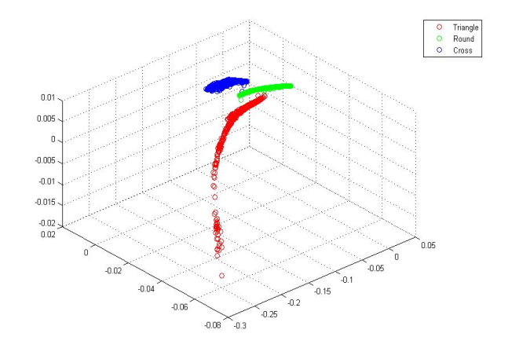
Once designated shape is detected, ASV must estimate location of docking bay. In order to do this, MACS integrate computer vision and lidar. If x,y position (pixel) of designated shape in image frame is known, by using x direction position, bearing angle (degree) of the shape can be estimated.
Figure 7 shows this relationship between x-position (pixel) and bearing angle. This relationship is determined by fitting experiment data into polynomial in a least square sense.
Once bearing angle of designated shape measured in body-fixed coordinate is known, corresponding distance can be measured by lidar. By using this distance value, location of the designated docking bay can be calculated. Figure 8 shows overall docking process using this method. After estimation of the location of docking bay, docking path is generated. Docking path is composed of arc and linear shape paths. Docking path guides ASV to tangential direction of pontoon with smooth motion change, reducing chance of collision.
Figure 7 Relationship between Bearing angle and x-direction position in image frame
Underwater Search
Figure 8 Docking Algorithm
In Task 2, ASV must estimate location of underwater acoustic device. This task is divided into two sub-tasks. First one is to estimate Direction of Arrival of acoustic signal. Paulo Cesar Prandel 's work for DoA detection was referenced. According to the approach, Generalized Cross Correlation method was used to estimate time difference of arrival between 4 different hydrophone in array, and this time difference of arrival was used to estimate Direction of arrival. Underwater Acoustic signal is digitized simultaneously by four hydrophone attached to ASV at a rate of 25kHz. Once sound of acoustic pinger is detected by deterministic loop, signals are transferred to non-deterministic loop for estimating DoA. Figure 10 shows detected acoustic signal from two hydrophones.
Figure 11 Estimation result of acoustic source location
Figure 10 Acoustic Signal measured by hydrophone
Once DoA(Direction of Arrival) is calculated, estimation of acoustic source’s location is necessary. So far what we have is only direction information at a given position. In order to estimate location of the acoustic source, particle filter was used.
Figure 11 represents simulation result of particle filter in estimating acoustic source location. Each green particle represents estimation result for acoustic source location. Particles are evaluated at each iteration by DoA measurement data. After evaluation, particles are resampled with their score. If a particle has higher score, it has higher probability of being resampled while resampling process. As time goes by, particles converge to a point and location of acoustic source is estimated with high certainty (small covariance).

Conclusion
After twelve months of time, team MoMo is prepared to present an ASV that is fully capable of operate in structured environment. Because operating environment is structured environment, MACS uses this information for decision making process in addition to sensor data in order to become more reliable and high performance vehicle.

References
Craig, John J. Introduction to robotics: mechanics and control. Upper Saddle River, NJ, USA:: Pearson/Prentice Hall, 2005.
Fossen, Thor I. Marine control systems: guidance, navigation and control of ships, rigs and underwater vehicles. Marine Cybernetics, 2002.
Johnson, Gary W. LabVIEW graphical programming: practical applications in instrumentation and control. McGraw-Hill School Education Group, 1997.
Katebi, Reza, and Qamar Saeed. "Nonlinear Predictive PID Control Design for Ship Manoeuvring." Manoeuvring and Control of Marine Craft. 2009.
Ristic, Branko, Sanjeev Arulampalam, and Neil Gordon. Beyond the Kalman filter: Particle filters for tracking applications. Vol. 685. Boston: Artech house, 2004.
Siegwart, Roland, Illah Reza Nourbakhsh, and Davide Scaramuzza. Introduction to autonomous mobile robots. MIT press, 2011.
Thrun, Sebastian, Wolfram Burgard, and Dieter Fox. Probabilistic robotics. MIT press, 2005.
Thrun, Sebastian, et al. "Stanley: The robot that won the DARPA Grand Challenge." Journal of field Robotics 23.9 (2006): 661-692.
Welch, Greg, and Gary Bishop. "An introduction to the Kalman filter." (1995).

