University of Hawai’i at Manoa: Team Kanaloa

Peter Joseph Agcanas, Raymond Andrade, Paul Baessler, Bradley Beeksma, Michael Borunsinski, Kekoa Data, Blaine Furman, Hunter Garrett, Dominic Gaspar, Danny Hong, Kai Jones, Serena Kobayashi, Cheyenne Marie Langamin, Yong Cong Li, Charmaine Lum, Lisa Mahan, Curran Meek, Kealoha Moody, Kai Outlaw-Spruell, Jordan Romanelli, Dane Sobol, Dr. Zhuoyuan Song, Daniel Truong, Dr. A Zachary Trimble, Allison Wong, Brennan Yamamoto

Abstract— Team Kanaloa is part of the Renewable Energy, Industrial Automation, and Precision Engineering (RIP) research group aimed towards the advancement of unmanned systems. Team Kanaloa is developing an autonomous surface vehicle (ASV) to compete in the 2018 Maritime RobotX Challenge held by Association for Unmanned Vehicle Systems International (AUVSI). The ASV will execute two tasks: Scan the Code and Identifying Symbols and Dock to demonstrate fundamental autonomy. The ASV compromises of a holonomic propulsion system, flexible wireless system, a modular mounting rack for hardware and sensors, 50V power system.

INTRODUCTION
Team Kanaloa, from the University of Hawai’i at Manoa, is a multidisciplinary group of, primarily, undergraduate students who aim to research and advance autonomous maritime systems. Team Kanaloa is developing the WAM-V to compete in the 2018 Maritime RobotX Challenge to demonstrate the student’s capabilities of developing an ASV. During the off season of the Maritime RobotX Challenge, autonomous capabilities of the Wave Adaptive Modular-Vehicle (WAM-V) is developed and utilized for side research projects.

Design strategy

Scan the Code
Completion of Scan the Code task starts using our developed Hue Saturation Value (HSV) threshold that classifies red, green, and blue. The WAM-V scans the pattern of the buoy twice, then reports the name and picture of the color to the user in order.

Figure 1: HSV to identify the color pattern.

Identifying Symbols and Dock
Completion of Identifying symbols and dock starts by identifying the shape located at the dock using a Regional Convolutional Neural Network (R-CNN) available on MATLAB. The R-CNN also identifies the location of the shape in the picture frame. Once the shape and location are identified, the WAM-V utilize the HSV from Scan the Code to identify the shape’s color. Then, the WAM-V detects the range from the dock using a LiDAR and the waypoint navigation code, the WAM-V will dock in the correct bay.

Vehicle design
This section describes the changes made to the mechanical, hardware, and software that was implemented. Descriptions of prior iterations, component choices, design approaches, and results shall be included.

Mechanical System

Team Kanaloa made several mechanical modifications and enhancements to its WAM-V, which are shown in Figure 2.
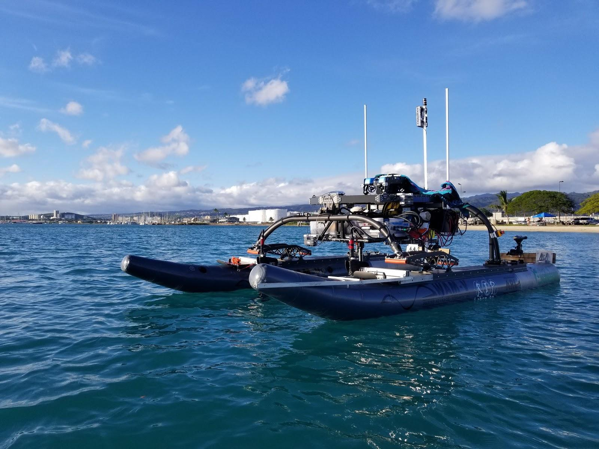
Figure 2: Team Kanaloa WAM-V

Propulsion System
Team Kanaloa utilized four 55lb thrusters in a holonomic drive configuration at the 2016 RobotX Challenge. Holonomic drive provides the WAM-V with three degrees of motion and precise maneuverability. However, the disadvantage of the holonomic configuration lied in the fixed positional angles of the thrusters. This was inefficient for fully moving forward or backwards compared to a normal drive train. Another issue became apparent when the ocean currents at a sea state level of 2 was able to easily push the WAM-V around during systems testing at Sand Island. Two solution strategies were developed to mitigate the problems: increasing the power of the propulsion system and developing articulating thruster mounts.
This year, Team Kanaloa decided to double the thruster force to 110lbs, mitigating the problem of not being able to hold position in certain orientation. However, to mitigate the efficiency disadvantage of the holonomic drive configuration, articulating thruster mounts were developed, providing the WAM-V the capability to mechanically change the propulsion system from a holonomic configuration to a normal drivetrain. The capability to switch from holonomic to normal provides the WAM-V with benefits of both drive configurations. Assuming the boat is moving at 3 knots and force is applied on the motor shrouds, computational fluid dynamics (CFD) was used and resulted in a max moment of 65 Newton-meters. Therefore, articulating thruster mounts were designed to utilize a worm gear, stepper motor with a torque of 12 Newton-meter, and a 1 to 5 gear reduction to combat the CFD max moment as shown in Figure 3.

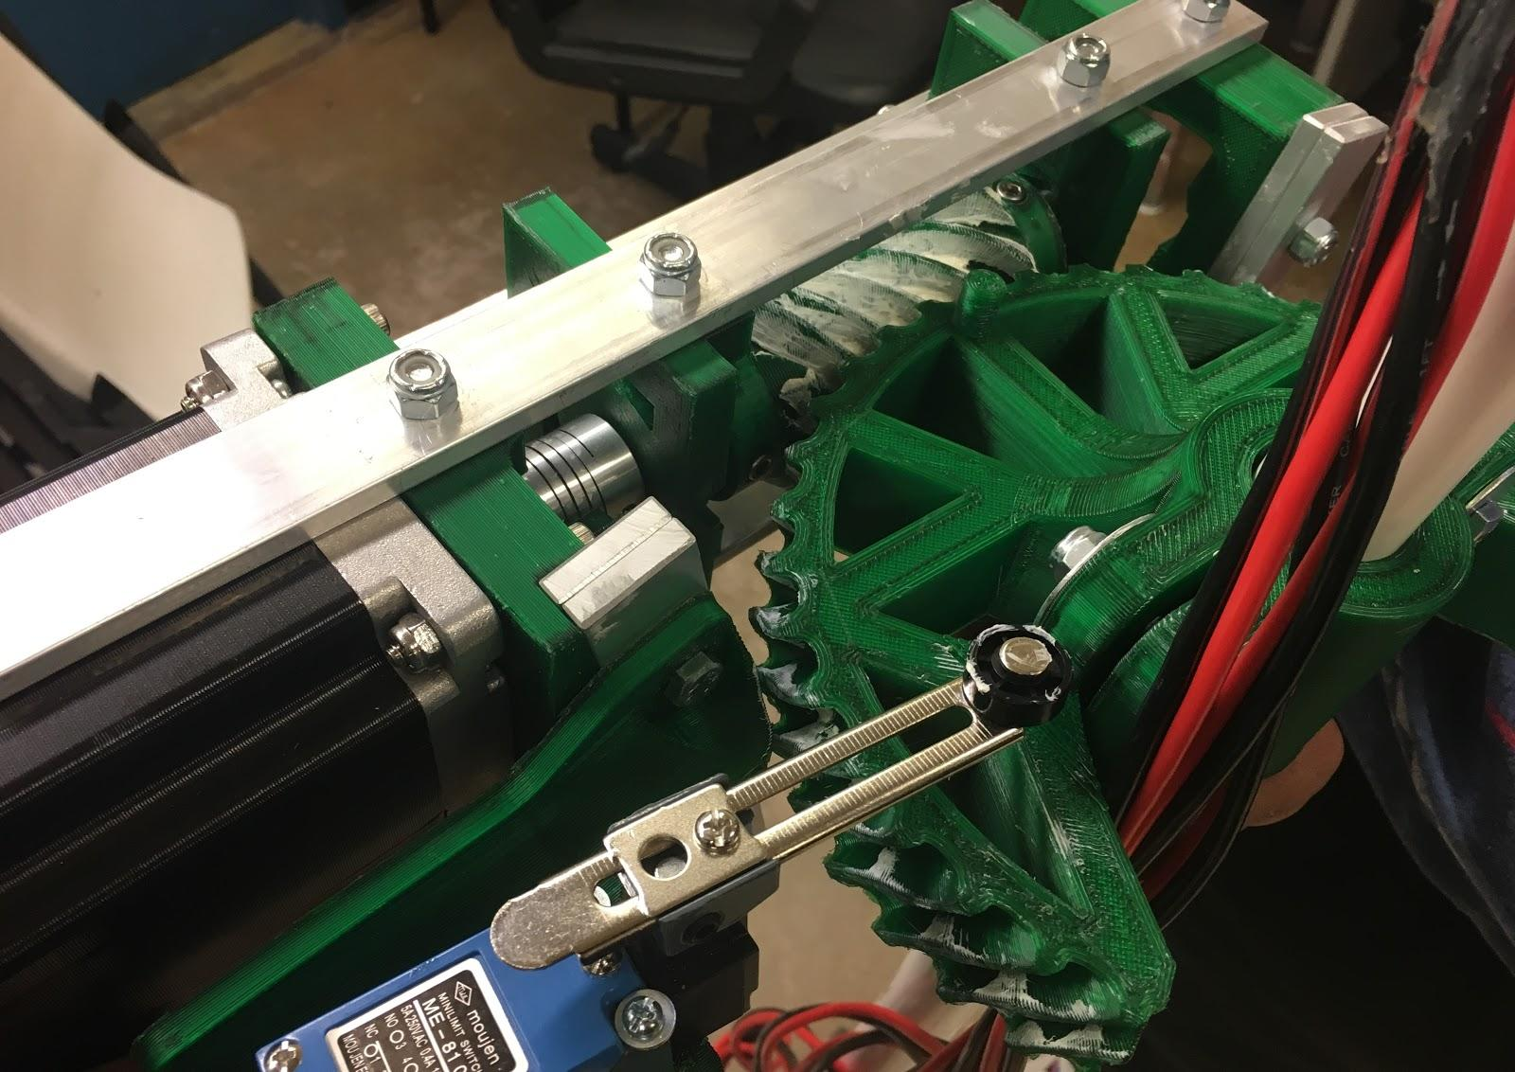
Figure 3: Top view of articulating thruster mount

Modular Mounting Rack
Team Kanaloa designed, prototyped, and developed a Modular Mounting Rack (MMR) as shown in Figure 4 for instrumentation on the WAM-V which includes the battery, hardware, and sensor system. The mounting rack was made to be mission adaptable for various instrumental setups.
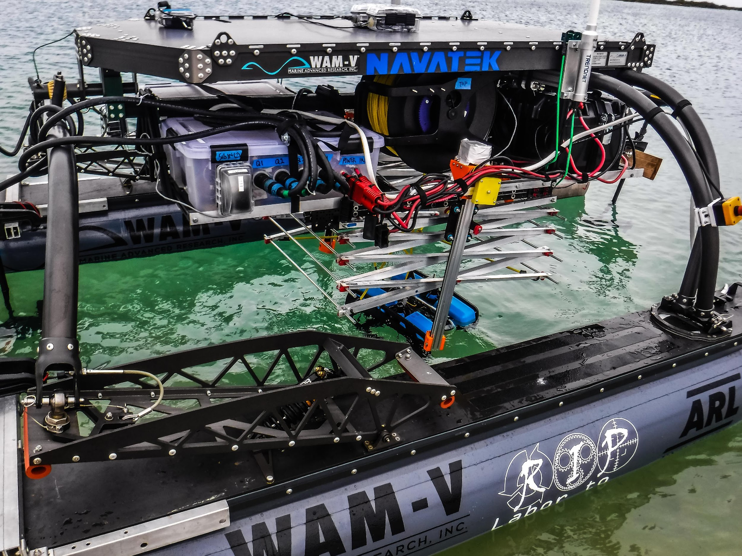
Figure 4: MMR

Power System
The team must upgrade the power system to accommodate for the new propulsion system of four 110lbs thrusters. In the old configuration, the team only required 12V for the 55lb thrusters, but 36V is required for the 110lbs thrusters. Due to Hawaii’s geographical location, battery shipments are expensive and difficult. Therefore, the team modified the current battery system by putting them in series, ultimately becoming a 50V power system.
Figure : 50V Power System

Hardware System

High Current Box
The high current box of the Team Kanaloa WAMV contains all components capable of effectively controlling a minimum of 50A. These components play the pivotal role of controlling the propulsion system. Effectively controlling the increased voltage requirement of the 110lbs thrusters required replacing the previous iteration of the high current box. The major change in the high current box was replacing the previous motor controllers, four REV Robotics Spark motor controllers, with motor controllers capable of inputting 50V from the power system. During testing of the motor controllers, it was discovered the motor controller’s internal voltage polarity inverter was inoperable after switching the polarity of a large amount of voltage. In other words, if the WAMV was required to go from full forward to full reverse in a short period of time, the WAMV would be unable to return to full forward. To circumvent this issue, external reverse contactors replaced the motor controller’s internal voltage polarity inverters. A 5V regulator was needed for a relay board on the reverse contactors; the relay board acts as a kill switch to the thrusters.
The previous motor controllers in the old high current system were controllable using pulse width modulation (PWM) signals. The new motor controllers operate on an analog signal. One possible option for sending analog signals was using a digital analog converter. This possibility was explored but had too many issues which couldn’t be resolved in a timely manner (see Ineffective Solutions section). The solution that was ultimately chosen was using the Arduino’s PWM pins with a low pass filter to replicate an analog signal. Low pass filters were designed for PWM frequencies of approximately 500Hz.
Another issue the new motor controller posed was increasing levels of interference in the high current box. This increase in interference caused digital signals to components, such as the relays, to float; resulting in uncontrollable rapid switching of power to the thrusters. To help remedy this issue, major rewiring was required.
Previously, the master Arduino (controls majority of functions in hardware box except power kill switches) read the voltage of the power supply directly using a voltage divider; with this information the master Arduino can better determine how much power the motor controllers can draw from the power supply preventing overdraw. With the new arrangements, an Arduino Mega was added to the high current system which primarily reads the battery voltage, then sends an analog signal to the master Arduino scaled based on the voltage of the batteries.
To ensure interference does not affect signals from the low current box system, which contains all components responsible for controlling the motor controllers, reverse contactors, and kill switch system, both the low current and high current systems are electrically isolated using optocouplers. Ten optocouplers were employed; five were used for digital signals to the reverse contactors; four were used for PWM signals to be converted to the motor controllers; one was used for the voltage reading Arduino.
Finally, to prevent overheating of components, a more advanced cooling system was required. The original casing of the motor controller utilized a heatsink and fan to cool the motor controller. This system wouldn’t work in a sealed box as the air wouldn’t be able to carry the heat out and away from the motor controllers. To solve this problem, water cooling allows the motor controllers to be rapidly cooled. The heat is carried by the water and brought to the external radiator to leave the system.
The high current box has multiple safety systems in place, which include relays, circuit breakers and the regulator disconnecting switch. These systems are designed to keep human operators safe and prevent damage to the other components in the box. The relays cut the power that is ultimately going to the thrusters, preventing them from spinning. This is done via the kill switch system, either by flipping a switch on the RC transmitter or by buttons located on the port and starboard sides of the WAM-V. The kill switch system sends a signal from these inputs and opens or closes the relay. The circuit breakers are designed to open in the event of a current spike going to the thrusters. This opening of the circuit prevents current from flowing, protecting the other components in the system. The regulator disconnecting switch is a circuit breaker with a different use. Functionally, it can perform all the previously stated functions of the circuit breaker. In this context, however, the circuit breaker allows for manual disconnection of the voltage regulator modules. When the voltage regulators were directly connected to the main batteries, sparking would occur at the junction between the high current box and the battery connection. Using the circuit breaker allows us to temporarily disconnect the voltage regulator from the main battery and thus preventing sparking.

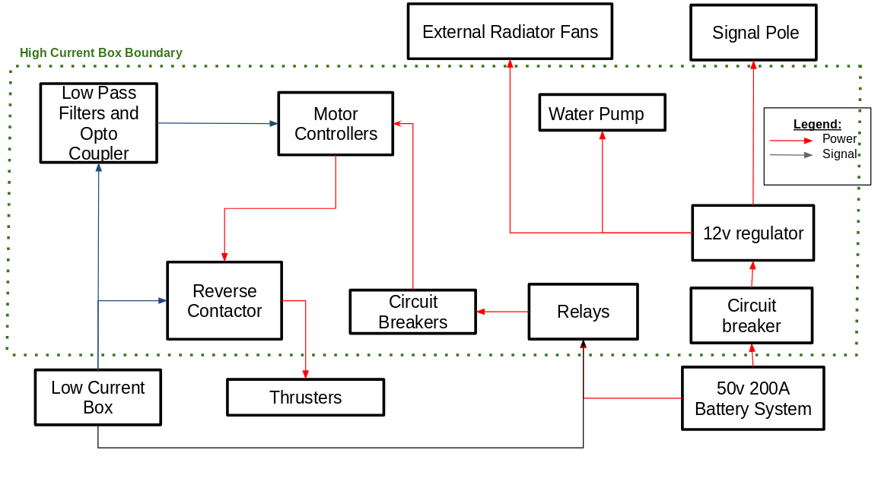

Figure 6: High Current Box Diagram
2) Low Current Box
The low current box received much less alteration than the high current box. The low current box contains components which requires less than 10A. As previously stated, the low current box as a whole is responsible for controlling the components as the high current box and ultimately the propulsion system.
The low current box receives signal from the wireless pole and outputs signals to the high current box. All three subsystems are connected using RJ45 Ethernet cables, which have been shown to be much better at maintaining connectivity in maritime conditions compared to the previous ethernet choices. In terms of power, the low current system operates on four 14.4V Lithium Ion batteries, totaling up to 290 Wh of energy.
There are three main components which make up most of the control electronics of the WAMV: two Arduino Megas and an Intel NUC. One of the Arduino Megas is designated as the Master Arduino; the Master Arduino is responsible for controlling the motor controllers and the reverse contactors. It can switch the WAMV between two modes: manual and autonomous. Manual mode allows a user with an RC transmitter on shore to control the movements of the WAMV. The other Arduino Mega is designated as the Kill Arduino. (See kill switch system section)
An Intel NUC serves as our onboard computer because of its compact size, compatibility with DC inputs which is how most components in the low current box are powered, and processing power. It functions as a platform for executing Robot Operating System (ROS) packages and autonomous code stored in its memory. The Intel NUC can also broadcast GPS location, odometry data, and camera feeds to the ground station using the onboard wireless router.
3) Wireless System
The Wireless System encompasses the Fr-Sky Receiver, the 2.5 GHz antenna, 5 GHz antenna, and the 900 MHz antenna. The Fr-Sky Receiver directly communicates with the manual controller and sends signals to the low current box over 16 channels. This component is located on the wireless pole, along with the 5 GHz antenna. The 2.4 GHz and 900 MHz antennas are mounted on the WAM-V platform. The various antenna, the 2.4 GHz, 5 GHz and the 900 MHz, allow for communication between the low current box and the ground station. The various antenna enables flexibility in networking options. In 2016, all competing teams used a 2.4 GHz frequency for wireless communications which caused interference. The ability to switch frequencies allows for avoidance of busy frequencies.
4) Ineffective solutions
During the design process, multiple solutions were proposed for the problems encountered. Most of these problems were related to the motor controllers in the high current system.
- MOSFET H-bridge
To fix this problem one solution was the MOSFET H-bridge. The H-bridge was constructed with 2 P-Type and 2 N-type transistors, allowing for the quick and reliable switching of voltage polarities; the motor controllers would only have to control speed. However, the H-Bridge is a complex and advanced circuit and proved to be difficult to build and control for high current systems.
The components in the H-Bridge, the P and N type transistors, were small. This made soldering difficult as the component had small surface to solder wires to. In addition, the transistor would absorb heat quickly during soldering, potentially damaging the component.
Controlling the H-Bridge had its own set of difficulties. The transistors had a low impedance on the signal side, which caused them to draw more current than the Main Arduino could handle, potentially damaging it. Resistors helped to solve this issue. Each transistor within the MOSFET H-Bridge is controlled individually using the Main Arduino. During testing using multiple transistors at once was more difficult than using a single transistor. Each transistor required multiple wires and took up a lot of space on the Arduino. The main issue with the H-Bridge was the tendency for the component to damage itself. If the transistors were incorrectly activated, then the circuit could short the battery within itself, damaging components and potentially rendering the circuit unusable. This situation happened frequently, and it was ultimately decided that the MOSFET H-Bridge would be a nonviable solution.
- Digital Analog Converters
As mentioned in the high current box section, one possible option for sending analog signals from the Master Arduino is to use a Digital Analog Converter (DAC). Originally for each motor controller, the design for controlling the motor controllers was to use 1 DAC for each motor controller (4 total). The DAC’s chosen were MCP4725 Breakout Boards. These boards communicated with the Master Arduino using I2C; unfortunately, with I2C each component must have a unique address and most marketable DACs have only two configurable addresses. The solution to this issue was to employ a multiplexer, the TCA9548A I2C Multiplexer, to moderate which DAC is communicating with the main Arduino. All these components were soldered on a protoboard.

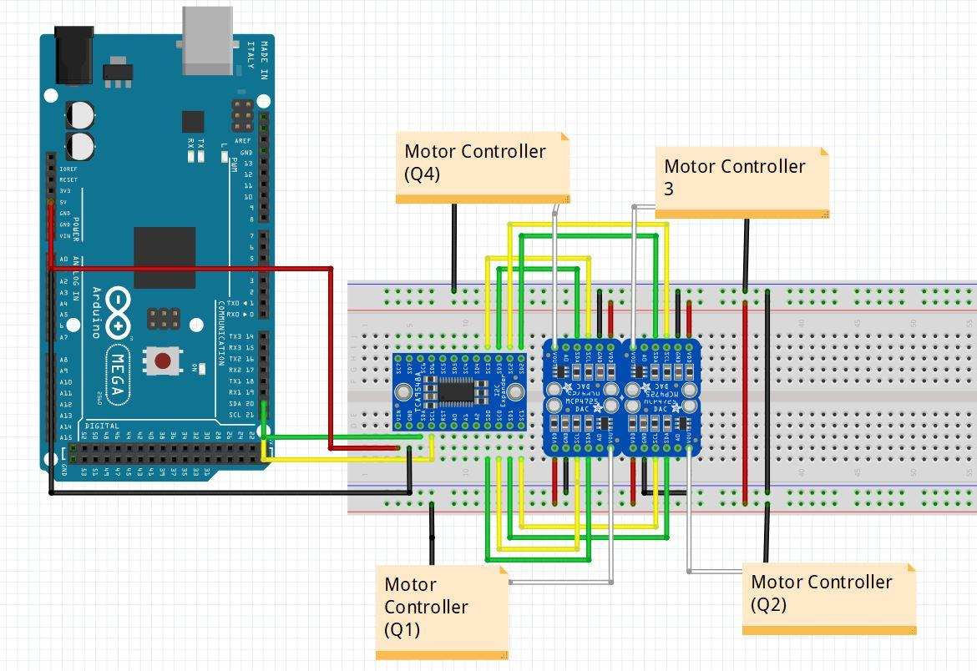
Figure 7: Wiring Diagram for Digital Analog Converter
While the solution seemed simple, there were many unexpected issues that propped up during the integration phase. The most prominent issue was interruptions and pauses in I2C communication. Occasionally, while the WAMV was in operation, one of the DAC’s would be unresponsive, sending a constant 2.5V (which was half the voltage supplied to it) to the motor controllers.
Multiple approaches were taken to fix this issue. On the protoboard level, much soldering work took place, either to replace a DAC that was suspected of being inoperable or to resolder a connection after a DAC was resoldered. From a system level, rewiring was the approach chosen. The initial attempt at integrating the DACs placed it into the high current box. Under the assumption that interference was affecting the SDA and SCL wires to the DACs, the DACs were moved to the low current box. The problem persisted.
Review of the data sheets for the MCP4725 Breakout Boards showed that the DACs may have a certain current limitation; if the design were to be repeated, adding resistors to the power pins of the DACs would reduce the chance of the internal components breaking. Also, during the testing phase, the DACs received multiple alterations to make compatible with the motor controllers which required re-soldering and removing pins. It is also highly suspect that the DACs were damaged thermally before being soldered to the protoboard. Regardless of the possible causes, a quick, inexpensive replacement was found by passing PWM signals through a low pass filter to produce a pseudo-analog signal.

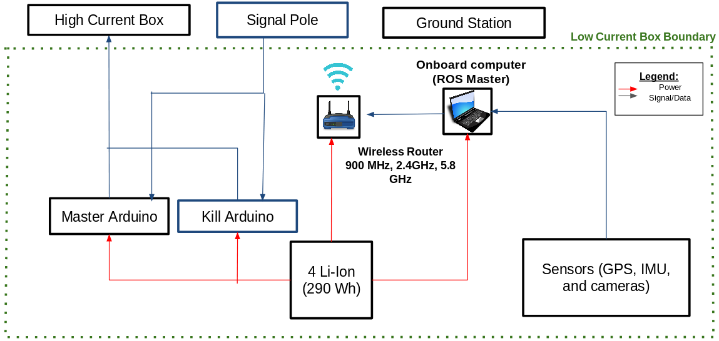
Figure 8: Low Current System

Kill switch system
The current kill switch system consists of a Taranis QX7 transmitter, a FrSky R9 receiver, an Arduino, two relay boards, two physical buttons on the WAM-V, and LED strip shown in Figure 10. Team Kanaloa previously used a Digi XBee radio module on an Arduino but changed to using a channel on a R9 receiver to send a kill signal to an Arduino. This change was due to the XBee having difficulty sending a signal over a distance of about 300 meters while the WAM-V is out in open waters. The Taranis QX7 transmitter paired with the FrSky R9 receiver can cover a distance just over 1 km. The operational procedure of the kill switch system is to have the Arduino monitor the state of the WAM-V via the two physical buttons attached to the WAM-V and a remote switch on the Taranis QX7 transmitter. If either of the buttons or remote switch is engaged, the Arduino sends a signal to the relay board which cuts power to the system. In the event the Arduino shall fail, the relay boards are configured to be normally open which kills the WAM-V system. In the event the transmitter loses power, the R9 receiver has a failsafe setting to send the kill signal to the Arduino. An LED strip is used to indicate the state of the WAM-V. This LED strip is also controlled by the kill switch Arduino via the second relay board.
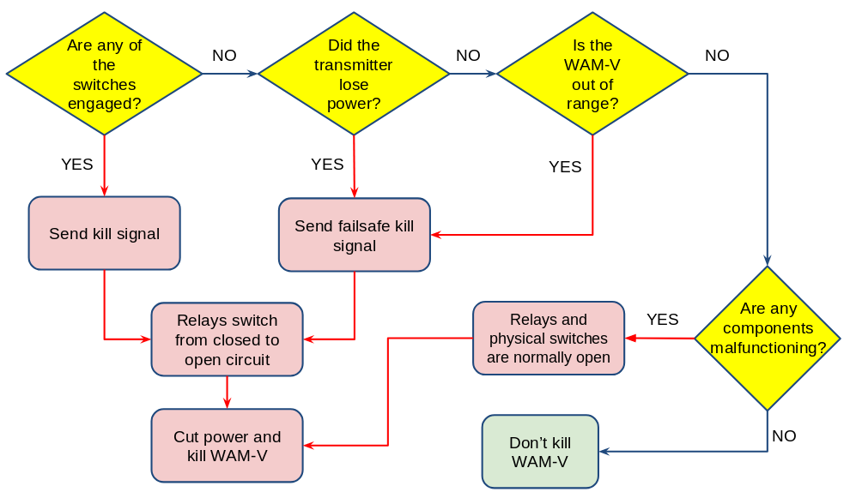
Figure 9: Kill Switch Chart
- Transmitter
The Taranis QX7 transmitter was chosen for its 16-channel configuration on a 2.4 GHz connection. 16 channels provide more manual control of the WAM-V system.

Software System
Team Kanaloa utilizes Robot Operating System (ROS), an open-source operating system for the team’s software platform. Since the team comprises of mainly mechanical engineers, the number of competent students in programming is small. Therefore, ROS allows the team to use drivers and packages that are already developed and add onto it, alleviating the amount of programming needed for the WAM-V.

1) Color Recognition
Running on OpenCV2 (Open Source Computer Vision Library) environment, the Color Recognition code is written in Python. The main factor in deciding to use Python and OpenCV2 was the experience and proficiency of the team members in said languages. The code itself subscribes to a node in ROS that publishes image data. Then the code identifies color in the image through HSV thresholding. Contours are then formed around the identified pixels to show and track where the identified color is in the video or image.
In initial testing of the code a simulation of the RobotX competition, developed on the platform Gazebo, was used. The simulation, Virtual Maritime RobotX Competition (VMRC), contains not only the WAMV but also sensors, including camera, and obstacles found at the competition. Most importantly is the “Scan the Code” obstacle: the light buoy. VMRC’s light buoy can be programmed to display any color or pattern of colors; which can be then captured by the simulated camera into a compressed image format. This simulated data was ideal for testing because of its ease of programming and availability. In the Figure 11 below is a view of the obstacle from the WAM-V’s perspective, on the left. Next to that image is the code’s color contrasted correction of the image used to determine not only the color detected, but also where in the image it detects it. Finally, on the far right, is the code marking the first image with a simple circle to help identify and track the detected color.
Figure 10: First Iteration
This is one of the first iterations of the code. In later iterations the contours’ color would not only match the identified color but also display the color’s name in text (Figure 11 ).
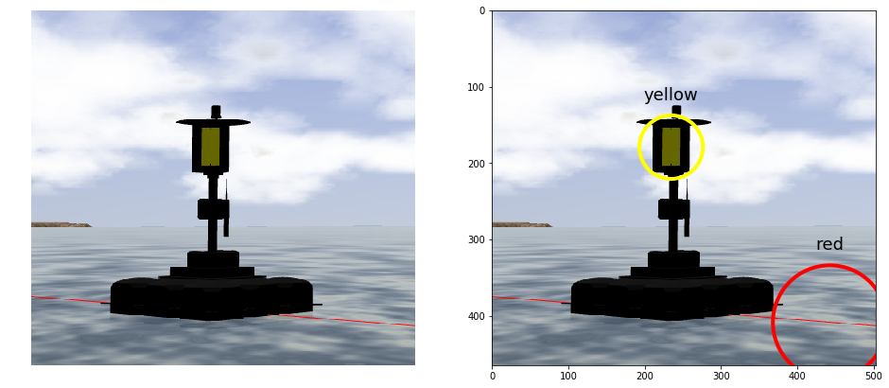
Figure 11: Final Iteration

The camera’s used for this, and other vision software on the WAM-V, were Logitech HD Pro Webcams. These were chosen due to their low price and USB compatibility. A ROS package, usb_cam, creates a node that interfaces with usb cameras and can publish image data to the onboard computer. This image data can then be sent to a second package, image_transport, which turns the raw image data into a compressed format. Compressing the images allows for less bandwidth being used over the wireless communication system and smoother live data at the ground station. The Color Recognition code will be run, manually, at the ground station so as not to take up computing power from the WAM-V’s onboard computer.

2) Image Recognition
The Image Recognition code was developed in MATLAB. Chosen, again, because it is the language that was most familiar to the team. Another factor for choosing MATLAB over other languages, was the many image and object detection algorithms offered with documentation. The team decided to use R-CNN detector, which allowed to train a neural network with images of the competition shapes supplied by the team itself. The detector returns the location of the objects with a labeled bounding box (Figure 13 ).
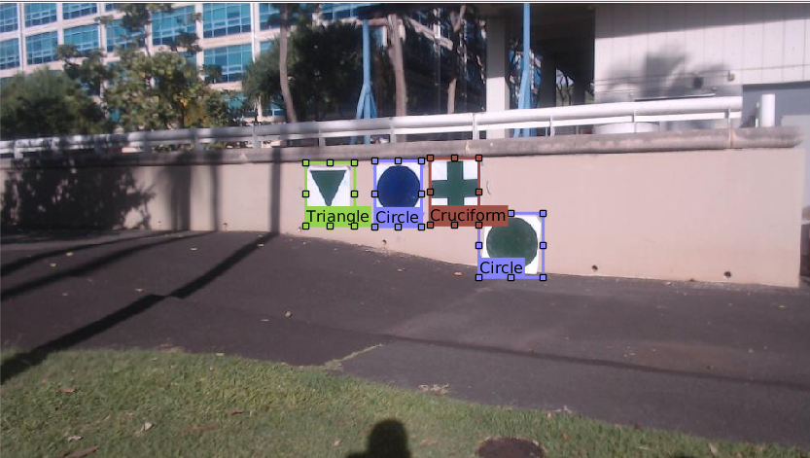
Figure 12: R-CNN Labeling
3) Robot Localization
The Robot localization code was developed in ROS [1]. A ROS package called robot_localization, meant to fuse multiple sensors from the sensor suite, two IMUs and a GPS, attached to the WAMV. The data is run through an extended Kalman Filter to produce a pose state estimate of the WAM-V’s position, orientation, linear and angular velocity. Once the code is activated its position at that time is used for the origin of the local and map frame for the code.
4) Waypoint Navigation
The Waypoint Navigation code was developed in MATLAB and designed to communicate with ROS. The position, orientation and velocity of the WAM-V is published in ROS; the MATLAB code creates its own ROS subscriber to receive this data. The code also creates publishers to the motor inputs and goal inputs in ROS. The goal inputs are simply the x and y position and orientation desired for the WAM-V.
Once the code has its odometry data it calculates the error in position and orientation; as well as the distance, in length and arc, to the goal inputs. From these errors the WAM-V is determined to be in one of 6 states. These states can be set into two main categories: facing correct heading or not. Each of these categories are then broken into sub-categories: outside approach radius, inside approach radius but outside goal radius, and inside goal radius. First the code rotates the WAM-V to face the goal. Then the code is set to drive the WAM-V forward and controlling the path heading toward the goal. Once the WAM-V is within the goal radius and facing the correct heading the code cuts off the thrusters. The radiuses can be adjusted depending on the precision of movement of the WAM-V and accuracy of the sensors. As of right now based on the accuracy of the GPS the goal radius is set to 3 meters. The code controls the speed of the WAM-V by sending messages for the thruster’s voltages to the Arduino controlling the propulsion system.

Experimental results

Finite State Machine
As mentioned in the section above, Team Kanaloa utilizes VMRC simulation for code and autonomous testing. The simulation contains important fundamental aspects of the robot and environment such as holonomic configuration, field test elements, and Sand Island simulation.
Using the simulation, Team Kanaloa was able to test image and color recognition, two fundamental capabilities to execute Identifying Symbols and Dock, and Scan the Code. For Identifying Symbols and Dock, Team Kanaloa used the simulation for training, validating, and testing data. Then, HSV thresholding was tested in simulation to identify color which utilizes OpenCV in python and sees if the color shares the same location of the shape that is recognized as shown in Figure 14.

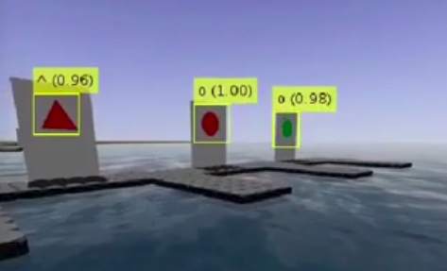
Figure 13: Example of Using R-CNN in Simulation
Team Kanaloa gathers color data by capturing compressed images of the three different shapes that appear in the “Identifying Symbols and Dock” task: triangle, circle, and cruciform. Each shape was painted by the team in red, green, and blue for a total of 9 shapes. The shapes were photographed at Sand Island with the cameras used on the WAMV. In doing so the background for each picture would be closer to competition conditions and would supplement the data with lighting conditions or other environmental factors.
Some challenges in simulating the workflow of the task includes making sure the WAM-V could classify multiple shapes and colors in one frame and anticipating color changes in various environmental conditions at the competition site. As for Scan the Code, the simulation was used to test the WAM-V ability to identify RGB buoy before testing the WAM-V in the actual competition site.

Field Testing
Team Kanaloa utilizes a three-stage testing system procedure to validate the compliance of integrated hardware or software before going on a field test at Sand Island. The three-stage system testing procedure consists of component testing, module testing, and full-system testing in that order. Each testing tier must follow an iterative testing procedure. Iterative testing involves performing a minimum of five trial runs in a row, that meet the experimental success criteria. A trial run consists of unplugging the component and resetting the system. Final validation is determined by a demonstration in front of the Project Manager or System Integrator after all the iterative testing procedures have been successful. All testing must be done two days before the field test day.

Field Element Construction
Take full advantage of being able to test at Sand Island, components like what will be used in the competition were constructed. Components for the task “Identify and Dock” and “Scan the Code” were designed to be easy to assemble and deploy out in the field. The parts that were created from materials that were on hand and what was easy to find. The floatation for the light buoy came from five-gallon buckets, with a counter balance attached to the pole.
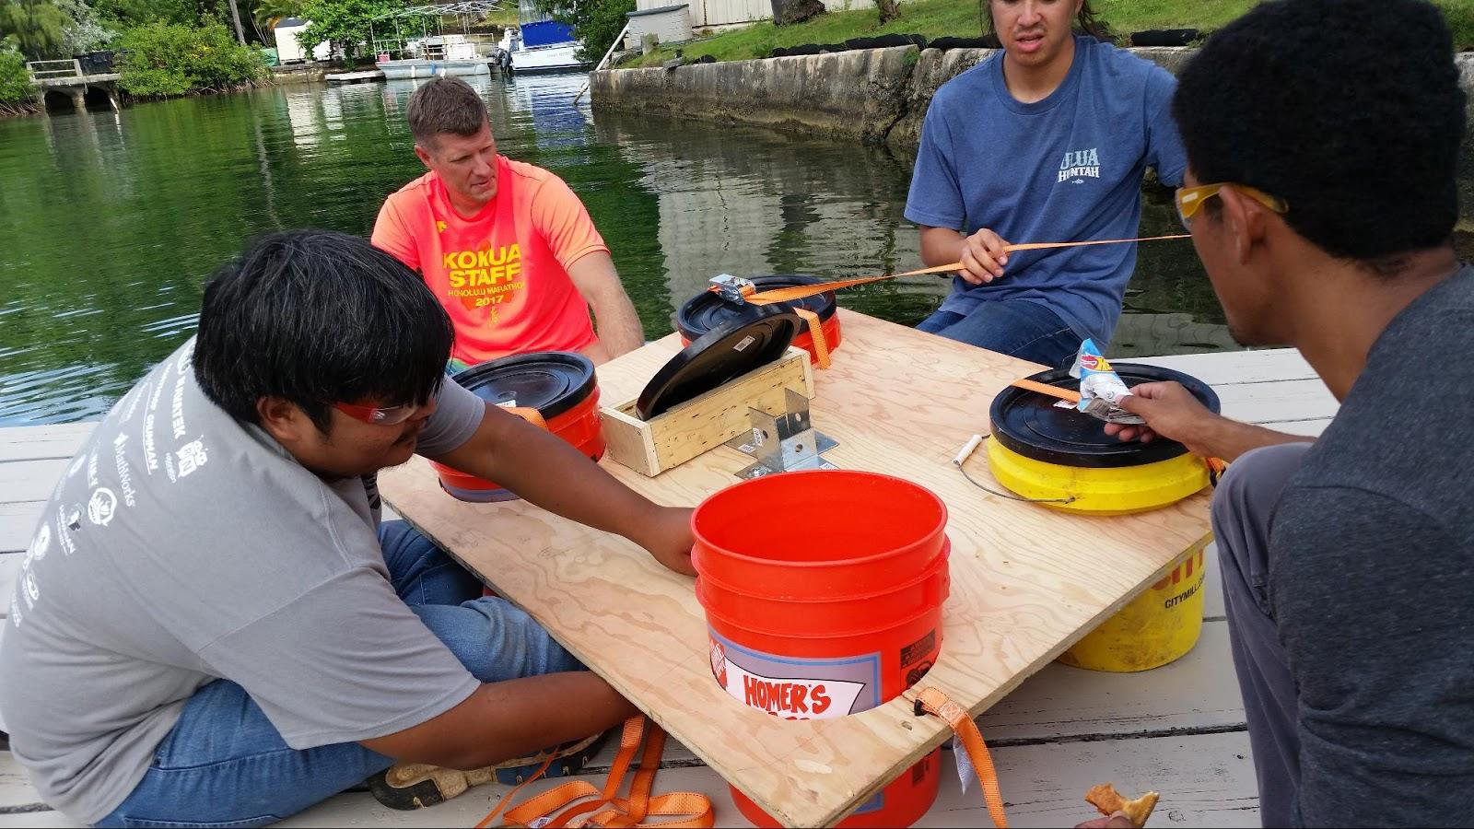
Figure 14: Buoy Assembly
Conclusion
In conclusion, Team Kanaloa is currently developing the WAM-V capable of executing two tasks that will develop fundamental autonomous behavior: Scan the Code and Identifying Symbols and Dock.
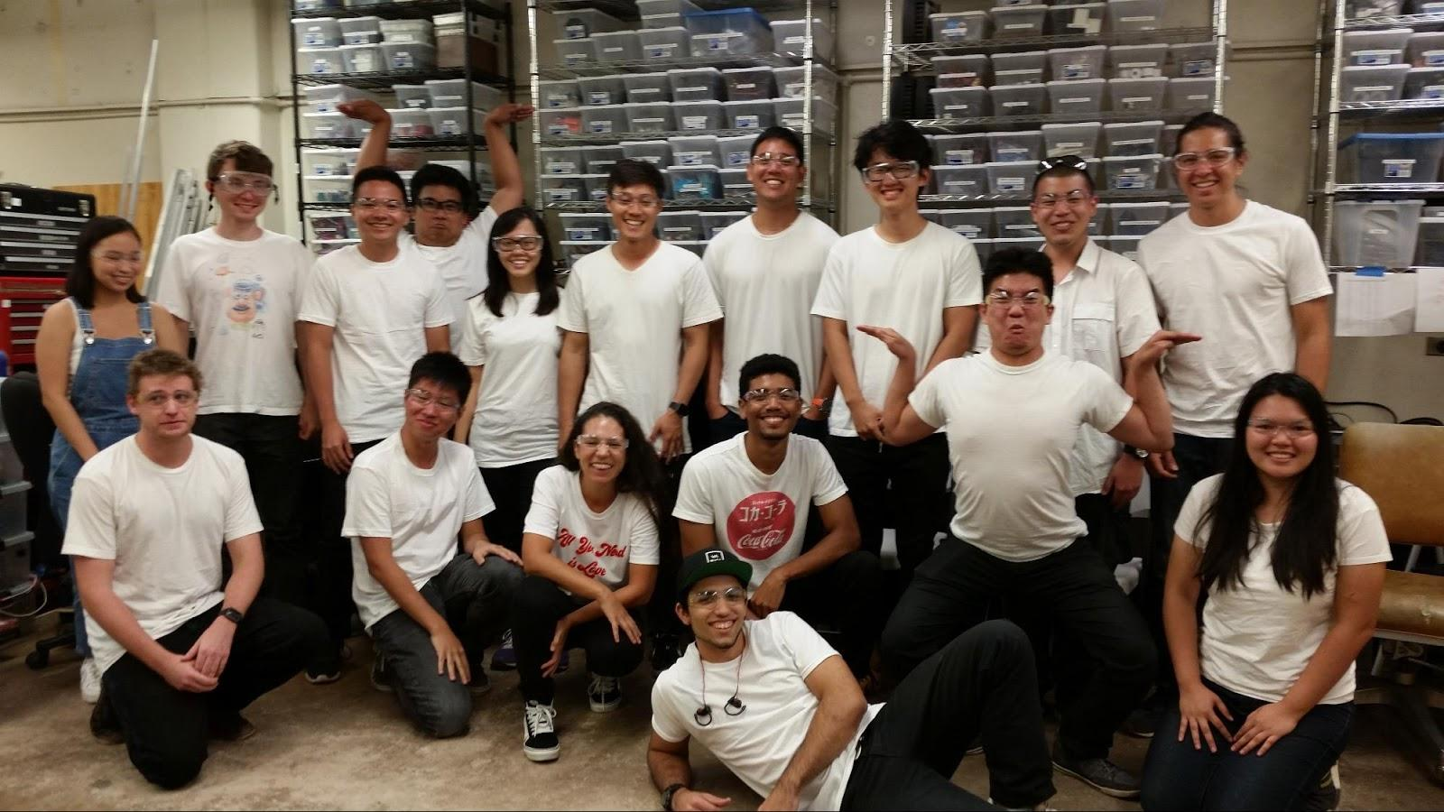
Figure 15: Team picture

Acknowledgements
Team Kanaloa would like to express gratitude to the following individuals who have contributed their money, time, and effort to this project:

Dr. A Zachary Trimble
University of Hawaii, College of Engineering, Mechanical Engineering, Director of Renewable Energy, Industrial Automation, and Precision Engineering (RIP) Laboratory

Anthony Sylvester III
Makai Ocean Engineering

Team Kanaloa would like to express gratitude to the following donations and sponsorships from the following organizations:
Applied Research Laboratory at University of Hawaii
College of Engineering at University of Hawaii
MathWorks
Makai Ocean Engineering
Office of Naval Research
RIP Laboratory at University of Hawaii

references
[1]T. Moore, “Working with the robot_localization Package,” ROSCon 2015, 2015.
The following PPT presentation is from the ROS official website. It goes into detail about utilizing the localization package and explaining the different files within.

[2] Y. Yun, J. Jin, N. Kim, J. Yoon, and C. Kim, “Outdoor localization with optical navigation sensor, IMU and GPS,” IEEE Int. Conf. Multisens. Fusion Integr. Intell. Syst., pp. 377–382, 2012.
Article is a survey paper about outdoor localization using the IMU and GPS. The article also goes into detail about some of the issues when navigating outdoors and various algorithms that utilize EKF localization to move within the space.

[3] N. R. Council, Autonomous Vehicles in Support of Naval Operations. 2005.

[4] [4] J. George and G. Ponnu, “REAL-TIME ROSBERRYPI
SLAM ROBOT,” Des. Proj. Rep., p. 55, 2016.

[5]

