Team BangaloreRobotics

LASSIE IV-An Autonomous Master-Slave AUV
System for ROBOSUB-2016
H Sriprada Adiga, Nischal Dinesh, Muthukumar Mahendra, Deepak Narayanan, Niranjan Dinesh

Abstract—Lassie IV is a concept designed for Robosub 2015 and 2016. The design features a dome shaped hull e.i. light weight, robust and cheap. The Dome Hull has a novel inflated Butyl tube gasket. The compact design structure makes it agile and more maneuverable. The AUV also features front and bottom cameras for the purpose of image-processing. It has depth sensor, compass and also features an IMU (Inertial measurement unit) controlled by onboard Microcontrollers and processors. The key feature of the design is that all the wires are inside the AUV making it reliable for real time applications.
- INTRODUCTION
Team BangaloreRobotics is a collaborative of Multi-University, Multi-disciplinary team of Enthusiastic group of Student members from various stream. This is the fourth year of association (since 2013) for the Team with AUVSI (Autonomous Unmanned Vehicle System International) and ONR (Office of Naval Research), which together conduct the annual event RoboSub which is a competition for Unmanned Under water Vehicle systems participated by Teams across the world. The main aim of the competition is to issue a series of challenging tasks under water which is to be completed by AUV.
The LASSIE IV is 4th in the series of design and competition
Effort of Team BangaloreRobotics.
The Design was evaluated mainly for the following parameters:
- Multiple Vehicles Master─Slave AUV system.
- Dome cap Hull.
- Inflated Butyl Rubber gasket.
- A simple and robust mechanical grabber.
- All the wires and Connectors are Embedded inside the AUV.
The team intends to continue this year with the Theme of Master and Slave design i.e. to use Multi-vehicle system both enabled to perform different set of tasks. The main design principles revolve around making the AUVs as light as possible and also to keep the dimensions to a minimal whilst supporting the mechanism to perform the tasks.
The fundamental design queue of using the dome continues this year but significant changes have been made to the overall design and also software algorithms used have also been enhanced.
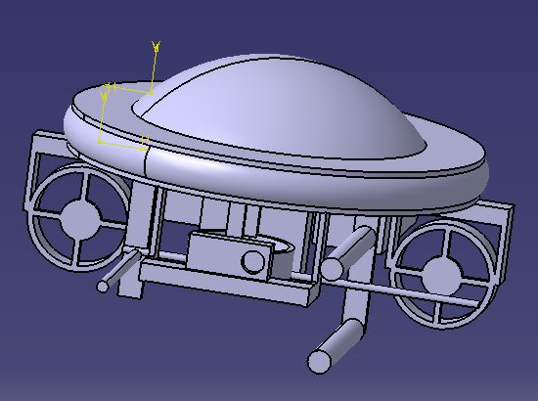
Fig 1: Catia model of the AUV
- DESIGN OVERVIEW

The key feature is the use of Multi-vehicle collaborative“ Master-Slave System” where both the Master and the Slave are capable of performing different tasks at the same time.
- The design’s central feature of both the AUV is the dome shaped hull, a new design concept compared to the more conventional underwater AUV designs.
- The Hull also acts as the frame of the AUV which reduces added complexity of building the frame around the Hull.
- The design is made to reduce the dimensions to a minimum so that the overall weight is reduced and contributes vastly to the agility of the AUV.
- The design has been made so that the AUVs are inherently stable.
- The Master and the Slave are provided with pixhawk/APM 2.5 IMUs (Inertial Management Units).
- The sensor use to gauge depth is the MPX 4250DP (Motorola Pressure Sensor) where the readings have been calibrated to provide the depth readings.
- The compass provided for the IMUs should be sufficient to provide the compass bearing of the vehicles.
- The vehicles are provided with cameras, one at the front and one at bottom. Both the cameras contribute to image processing.
- A 3rd Camera was added this year to detect color alone and to assist the Manipulator mechanisms.
- The vehicles use a four motor configuration for movement.

- Design strategy

The basic design principles are simple, make the AUV as light weight as possible, keep the dimension profile small and make the AUV agile. The AUV uses a Dome shaped Hull made of Acrylic with material density of 1.20 g/cm3. Previous experience of working with Acrylic proved to be easier to construct and manage.
The dome shaped Hull also proved to be an Innovative design concept compared to the conventional designs. The dome shape also contributes to better structural strength as the AUV must handle immense pressure as it goes deeper in the water.
The Green color of the dome is to enhance the AUV visibility as the color green is visible over a longer distance, which could prove vital for finding the AUV should it be lost for some reason. It is also for follow-the-leader strategy for Multiple Vehicles under water.
The AUV design has undergone major changes as the hull also acts as the frame to all the thrusters and also mechanisms used to perform some of the tasks. The AUV design is made so the vehicle is inherently stable and reduces the burden on the IMUs (Inertial Management unit).
The Intel Compute stick, the major processor used helped us to reduce the overall size of the hull compared to previous designs that also resulted in reducing the volume.
The theme of embedding all the wires and tethers used inside the AUV is also continued from previous designs. The mechanisms used to perform the tasks are made to be simple and dual purpose, keeping only the tasks in mind to avoid complications.

MECHANICAL

- MECHANICAL HULL

From previous year experience the hull design for both Master and Slave was made keeping in mind the size of the AUV.The hull design of the Master AUV consists of a dome attached to a base plate between which is an inflated tube to support the system as shown in Fig 1. Keeping in mind the size of the AUV the Master AUV Hull was designed to a dimension of 25cm diameter * 10 cm height. The Overall dimension of the AUV was found to be 35*18cm.
The AUV system is made using 300mm and 250mm Polycarbonate and Acrylic Domes. The water seal is an innovative inflated Butyl rubber tube, specifically the inner
tube of bicycle tyres. The tube is inflated to 40PSI and holds good under 80ft of fresh water.

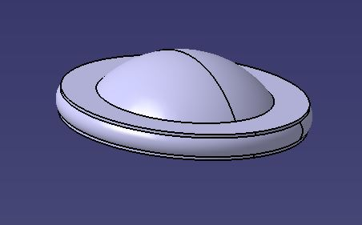
Fig: 2Hull Design with the Water proof inflated tube Gasket

- SCUTTLE SHIP GRABBER MECHANISM
A grabber has been added in the AUV aiming two tasks, the first to Scuttle ship task and to lift the bin cover.
The mechanism consists of two hollow cylinders fixed to a frame placed one above the other with a clearance as shown in fig 2. A screw rod run across these cylinders attached to which is a rod. The screw thread is driven by a DC motor.
The two vertical cylinders are also employed as the Torpedo Bay and Launcher.
For the “Scuttle Ship” task, the screw rod drags the cable horizontally between the two cylinders by the movement of screw rod which in turn will winch down the ship placed right above.
While in case of “Weigh Anchor” task, the mechanism behaves like a grabber to grab the bin handle and lift it up.

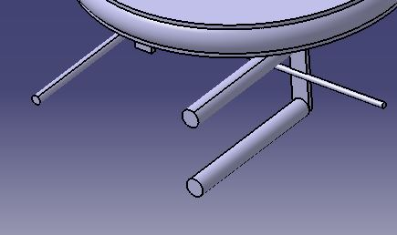
Fig: 3 Grabber Mechanism

- THRUSTERS

The propulsion system for both the AUVs will be provided by four brushless motors modified as water resistant Thrusters. Two motors are placed vertically down under the base plate along the pitch axis supporting the pitch and the vertical movement of the AUV. The other two are placed along the Yaw axis controlling the yaw and the horizontal motion of the AUV.

The AUV is designed in a way to self-attain stability in case of roll axis movement. This design would thus reduce the number of motors to be used and also reduce power consumption by the AUV.

- TORPEDO LAUNCH MECHANISM
The Torpedoes are held firm and out of sight inside 2 vertical Tubes in the front and below the Dome.
2 Servo motors launch the spring loaded Torpedoes.

- MARKER DROPPER
The Markers are similarly held within a single vertical pipe, angled and placed so that they can be released into the Bin.
Both these tasks are assisted and triggered by a 3rd camera Pixycam that can only detect Colors.

- The Bury Treasure task will be accomplished by the Slave AUV.
A hinged magnetic roller will try to scrape up the coin stacks. Atleast 3 may be captured easily, if and when the Tower is accessible.

- The Team does not have a Pinger Detector due to lack of funds and failure to find donors, but a Bat Detector was tried and works at only 15 ft. max distance.
The strategy is to position both AUVs near the Navigate channel, and move both forward at 90 degrees from each other.
While this was not tried till present, it will be done in the days before the event.

PROCESSORS/CONTROLLERS

1. PROCESSOR
The previous design incorporated was Intel NUC processor with dimensions at 116.6*112*51.5 mm which was a pretty medium sized unit for a full time processor. But the Intel Stick STCK1A32WFC with the dimensions of 32*103*12mm showed greater promise of further reduction in size and weight.
Intel Stick STCK1A32WFC comes with quad core Intel Atom processor with 1.33GHz speed. Low power input with 5V DC input voltage for processing and high performance made it better option than rest of the processors.
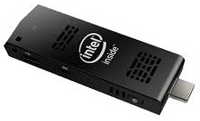
Fig 4: Intel Stick

2. PIXHAWK:-
The previous design used APM 2.5, an open source platform mainly focused on air and land based ROV platform and the open source code was tried to modify but presented a significant challenge to change it to an underwater AUV functionality. Hence pixhawk was used this time since it provided with the added benefit of using it for an underwater ROV although changes were still made to suit the needs of an AUV.
PIXHAWK is a high-performance autopilot-on-module suitable for fixed wing, multi rotors and all other robotic platforms. It contains ST Micro L3GD20 3-axis 16-bit gyroscope, ST Micro LSM303D 3-axis 14-bit magnetometer, Invensense MPU 6000 3-axis accelerometer and MEAS MS5611 barometer which makes it control 9DOF.The I2C port also facilitates use of external compass.
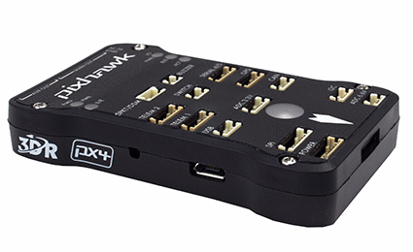
Fig 5: Pixhawk (IMU)

3.USB HUB:
The Intel stick has only one USB port, Hence an external USB hub is used to provide adequate ports to all the connections to the processor which include cameras, Arduino Boards, Mouse and keyboards. The USB hub contains 4 USB ports and is powered by power bank.
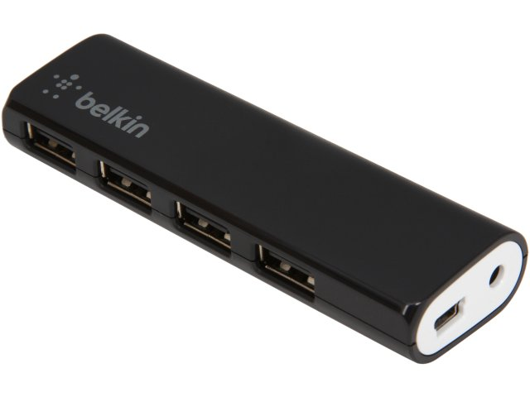
Fig 6: USB Hub

4. ARDUINO MEGA AND MINIPRO:-
Arduino is an open source hardware. Arduino Mega is designed with 54 Digital I/O Pins, 16 Analog outputs which makes it suitable for our Master AUV.
ProMini comes with 14Digital I/O pins and 6 Analog inputs.Its sleek design of 4.25*1.75*1.75 cm makes it easy to place with negligible space required.

5.BATTERIES AND POWERBANK:-
Two LiPo Batteries of 5000 mah power each, has been used in each AUV. Lipo Batteries are primarily used to power up 4 thruster motors. A Power bank of 10800 mah is used for powering up processor and other electrical components in each AUV.A casing for holding the Lipo batteries and Power bank has been added in the AUV.
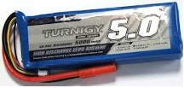
Fig 7:- 5000 mah Lipo Battery powers the Thrusters and motors
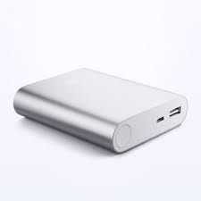
Fig 8:- 10A Li-po Power Bank for the CPU

The Li-Po batteries will be encased in a semi rigid Lipo safe bag and further dipped in silicone sealant for waterproofing.
Since Lipo batteries cannot be transported in person by air, the Team will source them locally in USA and process the waterproofing before the event.
Charging is outside of the AUV and requires removal of the batteries from the AUV.

- A set of hi power LEDs are distributed around the Hull to provide illumination of the Objects/tasks under water. 10W RGB Leds will scan a 90degree arc to enhance detection by the cameras.
The LEDs will also transmit encoded light to communicate between the Master and Slave.
This Light communication strategy was an attempt last year for inter AUV communication, but could not be demonstrated as the AUV was lost in transit at Abu Dhabi Airport. This year, the claim will be attempted and used for at least one Task during the event.

SENSORS

- CAMERA

The AUV will have two onboard cameras, one will be placed at the front portion of the AUV near the grabber mechanism and the other will be placed at the center of the base plate facing downwards to facilitate bottom sensing.
Both the cameras used is manufactured by Logitech.
The front camera will be using Logitech 9000 pro.Logitech 9000 pro has a Field of view of 75˚ (FOV), 640*480 screen resolutionand 30 frames per second (FPS) capture rate. All the above features made it to be used as a front camera.
Aditional Fisheye lens are also attached to the cameras and subject to the performance at the SSC Transdec, they may be used to enhance the FOV.
The bottom camera is Logitech C170 webcam with a 58˚ Diagonal field of view, 640*320 resolution and 30 Frames per second. A casing will be provided to both the cameras.
A new technique is used this year with an additional third camera.
PIXYcam is used to assist the tasks to identify colors only. It is trained to identify the Weigh Anchor bin handle and the Set Course door hook.
The Pixycam will also ‘follow’ the Master when necessary and can be guided through coded color light sequencing. This method was tried and inter AUV communication underwater through color coded ( Morse Code) light propagation using Pixy was tested with moderate success.

Additional Hi power RGB lights are deployed in both the AUVs. The intention is to sweep the arena and illuminate the Objects with selective colors for an enhanced range with respect to ambient light.
Pool tests were encouraging and did increase the probability of color detection with 20W of RGB power LEDs.

- DEPTH SENSOR

Two Depth sensors are used in the AUVs. MPX4250DP and MPX5999D Differential were donated by NXP. They were modified for underwater sensing.

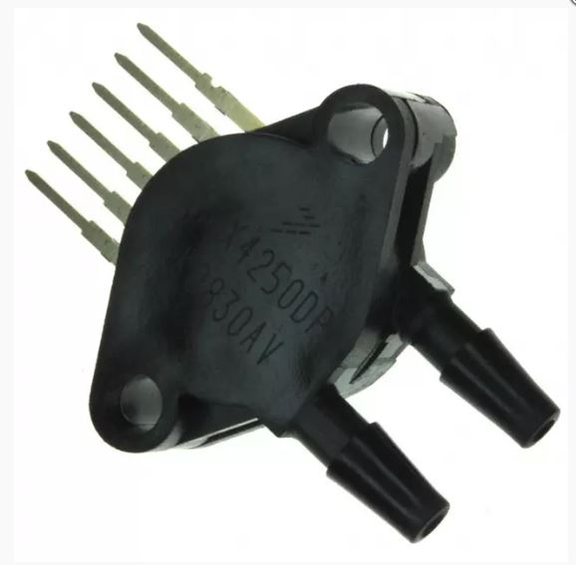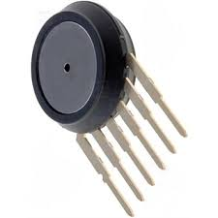

Fig 9:- MPX4250DP and MPX5999D pressure sensors
Testing and calibration showed good result in measurement of depth in water. The compact size and fairly accurate calculation of depth made it to be used as depth sensors.
Analog O/P signals are passed by the Depth sensor which is fed into the analog pin of the Arduino mega which in turn converts analog signals to binary data and transfers signal to the processor.

- The Kill Switch is a Magnetic contact breaker which disconnects power from the Motors. This will be a red ring that can be easily seen and pulled by the Divers.

Functional overview of Lassie IV AUVs
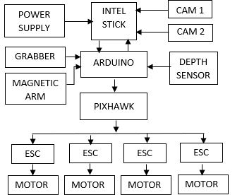
Fig 10: Functional Block Diagram of Master AUV

The Master AUV processor gets the data for image processing by both front and bottom cameras. The depth sensor is connected to the Arduino. The data received by the Arduino of depth sensor is sent to the processor. According to all data received, the processor commands thesignal to be transferred to the motors.
The binary data from processor flows to Arduino and is converted to digital and analog signals as per the command of processor. These signals then move into pixhawk.The pixhawk controls the stability of the AUV hence all the signals regarding motors should pass through it, as in case if the AUV destabilizes then the pixhawk will override the processor command and send signals to motors to stabilize the AUV.This process cycle is shown in Fig 7. The Master AUV consists of two mechanism one is the grabber and the other one being magnetic arm.
The procedure followed is similar in case of Slave AUV also as shown in Fig 8. But the mechanism carried by the slave is different.

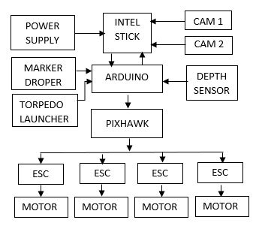
Fig 11: Functional Block Diagram of Slave AUV

SOFTWARE
The software used in LASSIE IV starts from image processing tool RoboRealm, different modules in this software tool perform the image recognition and also provides the Centre of Gravity of the image being processed.
Based on the task, different modules are used for colour and shape detection and coding is done using VB script. The coding in VB Script provides the necessary control signals to the thruster motors and other mechanisms for the tasks to be performed. The control signals of the Roborealm are given as inputs to Arduino mega with a pre-loaded sketch to give the necessary PWM values to run the thrusters.

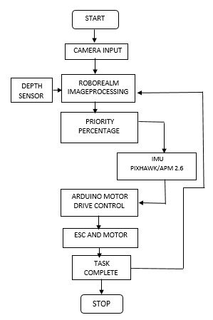
Fig 12: Flowchart of image processing

QGROUND CONTROL:-
QGround control is an open source software which provides full ground station support and configuration for pixhawk.The firmware is uploaded to pixhawk using QGround control.

CONCLUSION
- The emphasis was multiple vehicles that can facilitate autonomy and enhance mission capabilities.
- The light weight of the designs need low power budget.
- The mission time of useful deployment is comparatively longer.
- Limited budget and time constraints have limited the number of innovative ideas to a lower number than desired.
- A major part of the Design was the Mechanical and structural Variations.
- The innovative Butyl Rubber cycle tube performs quite well.
- The modified multicopter BLDC motors are successful and have not failed till now.
- Light communication is also satisfactory and can be improved upon till the event time.
- The Sonar has been a issue and could not be solved till the submission date, but may be possible in the remaining days.

- Though the Team lacks pool facilities in India, much of the work was done in the 25 hrs spent during pool maintenance days and nights.

ACKNOWLEDGEMENT
The Team is thankful to Association for Unmanned Vehicle Systems International (AUVSI) Foundation and Office of Naval Research (ONR) for providing this opportunity to participate in the Robosub 2016 competition.

The Team is also grateful to Dalian Humanities University DLNU, China, for allowing their Masters students to work with Dr Venkatesh, the Team Mentor, to participate in the Robosub event for the second year.

Team BangaloreRobotics
Members list

First Name | Last Name | Task
Gurappa | Venkatesh | Team Mentor
Arul | Vishwanathan | Team Advisor
Wang | Haiyan | Team Advisor
Nithyananda | R S | Student Advisor
Sriprada Adiga | Herdejadd | Roborealm image processing coding, Design of Hull, Paperwork, Electronics, Grabber mechanism
Nischal | Dinesh | Arduino,Pixycam Depth Sensor, Pool Testing, Torpedo system.
Deepak | Narayanan | Pixhawk, Cameras
Muthukumar | Mahendra | Arduino, Poster, Webpage management
Niranjan | Dinesh | Marker Dropper
DLNU Team (China) |  | Hull Design, Thruster

