System Design and Hardware Development of

Autonomous Underwater Robot “DaryaBird”

Ryota Nakanishi, Jonghyun Ahn, Katsuaki Suzuki, Yuki Soejima, Koji Masuda and Yuya Nishida

Abstract— "DaryaBird" is an autonomous underwater robot, is being developed by Kyushu Institute of Technology (Kyutech) Underwater Robotics research group. We improved our underwater robot, in particular, by installing an acoustic positioning system developed by our research team. An image processing system is used to different tasks in all challenges, so that we improved the object recognition rate and the estimation distance. To improve the accuracy of the acoustic positioning system, sound wave arrival angle estimation was improved. For the first time, object grasping system is developed and install in the robot. Object grasping is very challenging task especially with underwater robots, but we are planning to improve it as a prototype for a successful future. In brief, this paper has put more attention to present current improvements of the robot in details together with the experimental results in addition to the overview explanation of the DaryaBird.

INTRODUCTION
Autonomous underwater vehicles (AUVs) plays a great rale in the activities in deep oceans [1] and are expected as the attractive tool for underwater developments or investigations. Developing AUV is a big challenge solving various issues such as motion control, sensor data acquisition and fusion, decision making, self-localization, collision free navigation, etc. the robot should be capable of making decision monitoring the sensor information, and controlling actuators performing self-behaviors with minimum assistance of the operators. AUV is expected to be fully autonomous with adaptive functions to their environmental changes. Therefore, we have been investigating and presented adaptive control systems [2], [3], navigation system [4] and an underwater manipulator system [5].
As a team of underwater robotics, we are responsible for improving and developing DaryaBird including latest technologies and targeting towards producing a handy enough AUV for underwater robotic field.

DaryaBird
“DaryaBird” has a meaning of “gull” or often referred to as “seagull” in Persian language. The main design concepts of DaryaBird can be summarized as below.
- Small and handy enough to complete mission by a few operators.
- Frame structure for adding new parts and options.
- Selectable operation mode, AUV or ROV mode, depending on mission.
Older DaryaBird equipped battery and PC in main hull. It caused difficulties when opening the main hull for changing battery as well as it was a time consuming task. And, it may provide a chance to damage the PC because it is installed in the same hull messy with lot of cables. We remodeled our robot DaryaBird to overcome such kinds of design and constructional drawbacks. The concept we used for remodeling the robot can be explained as below.
- Cable less design for easy maintenance
- Suppression of trouble by introducing an extra pressure hull for battery
The specifications of the DaryaBird is given in the Table 1. More information about the whole system can be found in [6].

Specifications of DaryaBird
Facility | Description
Structure | Aluminum pressure hulls ×3  Mission module ×2  Aluminum T-slotted frame
Dimension | H413 × W506 × L830 [mm]
Weight | 35[kg]
Thruster | 110[W](BTD150) ×4  90[W](HIBIKINO Thruster) ×2
Controller | Board PC(Intel Core-i7)
Communication | Ethernet and Optic LAN
Sensors | Pressure sensor(Depth sensor)  Doppler Velocity Log (DVL)  USB Camera  Attitude sensor  Hydrophone
Batteries | LiFePO4 12[V] 9[Ah] ×3

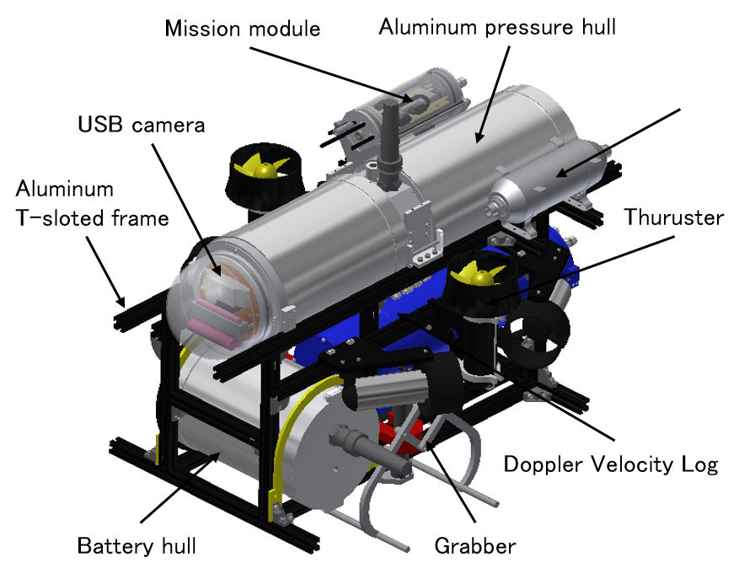
Fig. 1. Exterior view of DaryaBird

Kyutech Underwater Robotics
Kyutech Underwater Robotics is one of the Japanese underwater robot developing group including master students and doctoral students working together. Group basically consists of expertise in specialized fields of mechanics and electrical and software.
Our goal is the acquisition of a wide range of latest knowledge in the areas such as mechanical designing, electrical circuit designing, software development and reliability engineering. Underwater robot competition has become interested because it mimics the real-world challenges, hence it provides opportunities to learn applications of technologies practically. Furthermore, since the tournament is carried out in a various environments, robust designing of the robot that can be adaptable for any environment can be mastered.

Design Strategy
In the competition, challenging tasks were “Gate”, “Guide” “Buoy”, “Time Portal”, “Recovery Area”, etc. but we could only cleared the “Guide” and “Buoy” last year 2015 [7]. Main reasons for such problems happened in last year are:
- Sound source based localization system was much erroneous because the low accuracy of the hydrophones and we did not use localization correction method.
- Lack of time available for the development of software because of the time consumption for hardware development.
At first, in this year, we could finish developing and troubleshooting the whole of software system. We improved the accuracy of the object detection algorithm based on the image processing techniques because it is the base for all tasks. Further, basic orientation control of the robot (e.g. Heaving, Yawing) was experimented because it is very important to make proper motions.
Secondly, we improved the accuracy of the sensing unit, in particularly, acoustic positioning system was improved which gave inaccurate bad readings in the basic experiment. Finally, object grasping mechanism was tested and analyzed aiming to get ready for object grasping challenge. In the experiments, this task showed a high score though it was a very difficult challenge. We decided to develop the prototype of the grabber to the success of the object grasping the future.

vehicle design

Mechanical System
In the designing of the mechanical system, there are different parts were developed and they can be explained individually as below.

Main Hull and Middle Part
Main hull which is in the rear part of the robot contains PC, Motor driver, Power board, Communication unit and sensors and it is connected to the front side hull by the middle part. Middle part holds electrical parts such as connectors and circuit boards for thrusters, sensors and motor drivers. The middle part is designed to minimize the connection problems. Connectors are normally mounted on the outside of the hull. When robot is needed to be maintained, all the connectors had to be removed carefully one by one which takes considerably a large time with the previous design. By introducing the middle part to the system allowing to bring all these connectors to center of the robot, it makes easy access to the internal parts and maintenance of the robot. Moreover, these pressure hulls are designed to hold the pressure up to 50 meters of depth.
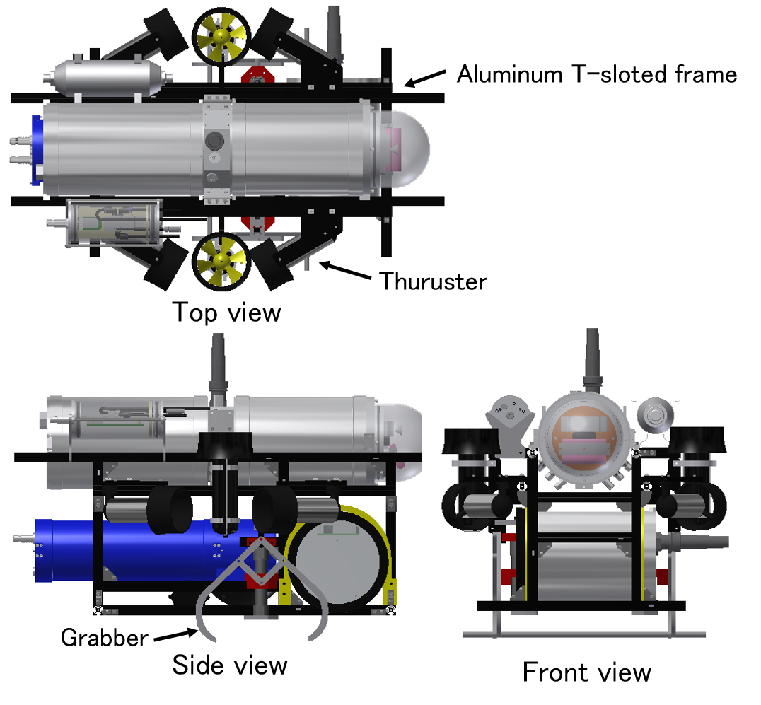
Fig.2. Three view of the DaryaBird

Battery Hull
DaryaBird uses four LiFePO batteries that are installed in the battery hull for easy maintenance. Inside the battery hull, we use current sensors and voltage sensors . (INA 226) These sensor values are transmitted to communication unit using arduino nano. The battery hull has transparent acrylic cap and LCD module.

Frame
We use T-slot frame as the Main frame for DaryaBird to assemble all the necessary components as shown in the Fig. 2. Two pressure hulls, DVL and other parts are mounted to the aluminum T-slot frame. External devices can be attached or detached on any place on the frame by using T-slot.

Thrusters, Other Components and Arrangement
Four thrusters (BTD150) are attached in front and rear of the robot as shown in the Fig. 2. These thrusters control surge, sway, yaw motions of the DaryaBird. Two more thrusters (called HIBIKINO Thruster) are attached across the central section as shown in the same figure. These thrusters control heavy, roll motions of the DaryaBird. Main hull, air tank and hull for grabber are fixed in the upper part of the vehicle, because they have a large buoyancy. Battery hull and DVL are installed in the bottom part of the vehicle, because they have high gravity. In this arrangement of components, buoyancy and gravity act effectively for stable posturing of the DaryaBird.

Grabber
The grabber is designed for grasping and holding the objects during the mission which is attached in the bottom covering left to right sides of the robot. Basic overview of the grabber is shown in Fig. 3 CAD drawing explaining how it acts to grasp the objects. The basic design concept of this grabber is to hold the given two simple objects same time. Grabber mechanism is much simple and consists of pneumatic linear cylinder, link mechanism and poles. The gripper can catch two objects in the plumb direction at a time, because a long poles connects the finger-tips. The link mechanism lets the excursion of the finger-tip spread by an amplification of the excursion of the Pneumatic Linear Cylinder.
Fig. 4 shows two instant situations of the grabber operation opening and closing of the finger tips. This is operated pneumatically moving the shaft connected to the four-bar mechanism of the grabber up and down.
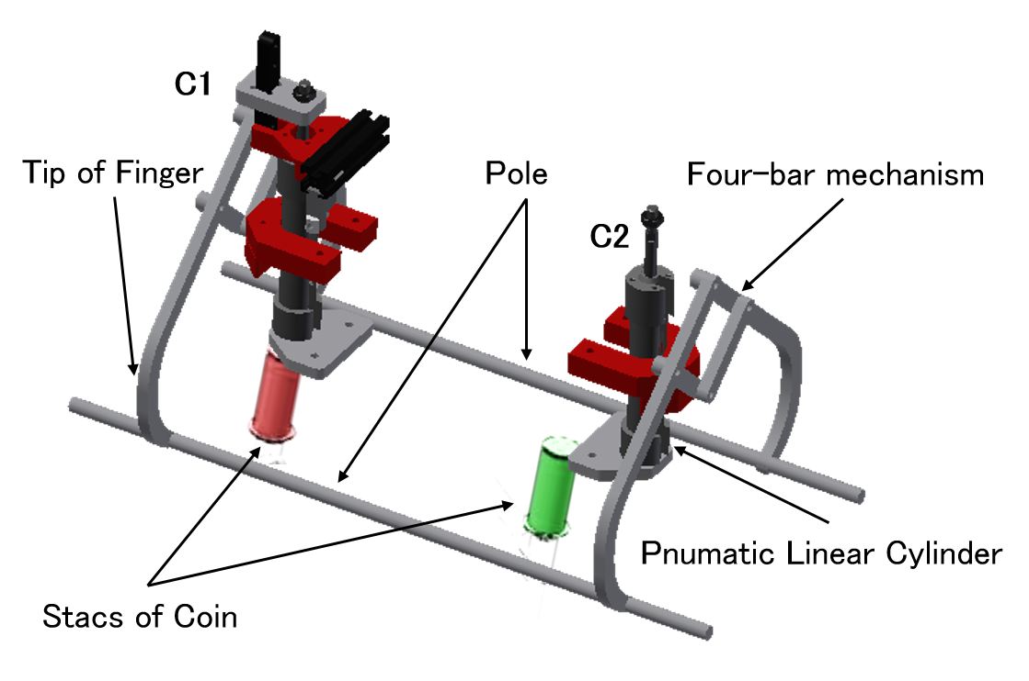
Fig. 3. Hold Image of the objects

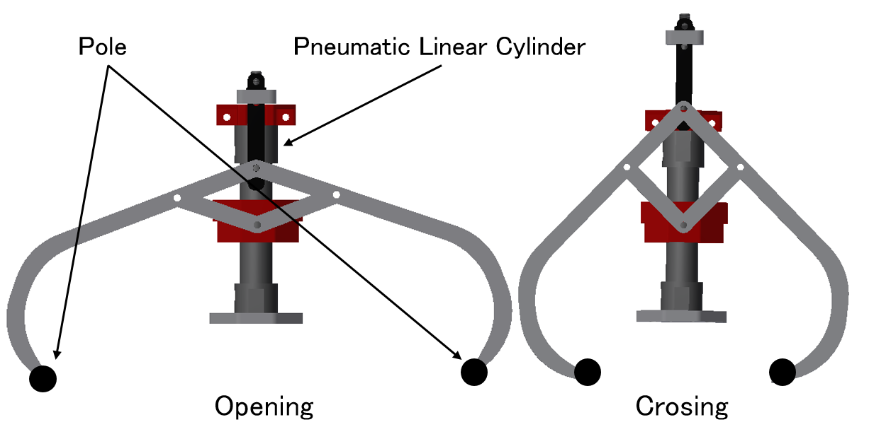
Fig. 4. Grabber

Grabber hull is fixed at the top right of the DaryaBird as shown in Fig. 2. It contains solenoid valves to control air cylinders, electronic circuit to control solenoid and other necessary components for grabber operation as given in Fig. 5. Additionally, a check valve is installed on the hull for dusting air. By air is discharged from air cylinders cause air to collect in grabber hull. Check valve can dust air that to collect in grabber hull. And Grabber hull can be waterlight condition.
A compressed air tank is fixed top left of the DaryaBird, opposite to the grabber hull that provides necessary air for pneumatic operation. Its capacity is about 0.75[L] and tank weight is about 0.74[kg].

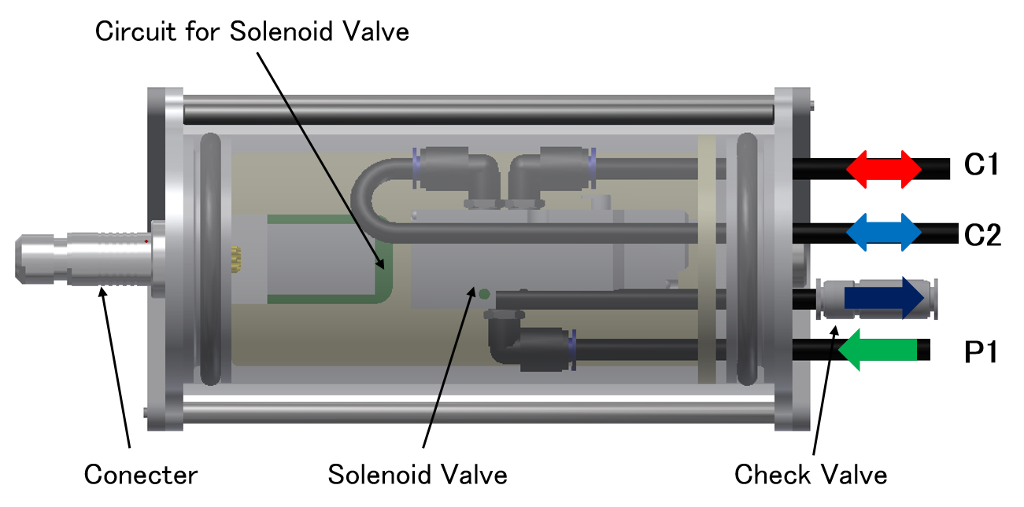
Fig. 5. Hull for grabber

Electrical System
The main circuit board consists of three units, motor control unit, power source and communication unit. Motor controller unit and power source unit are connected with the backplane board as shown in Fig. 6. Motor controller unit signal lines are connected to the communication unit shown in Fig. 7. Detailed system architecture of DaryaBird is given in Fig. 8. Sensors and motor driver standard communication is done through RS232. Communication unit has two functional modules, first, the signal level conversion module (ADM3202) convert RS232 to TTL level and second is FT4232H module to interface USB 2.0 to UART.
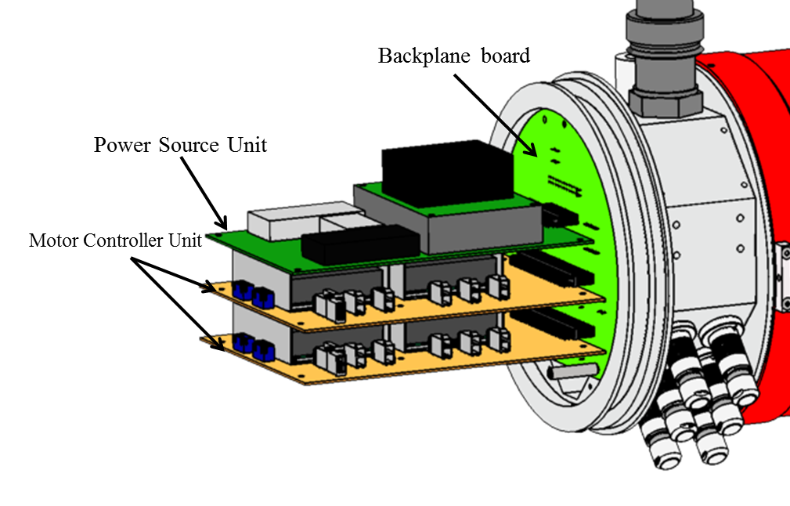
Fig. 6. Electrical circuit unit

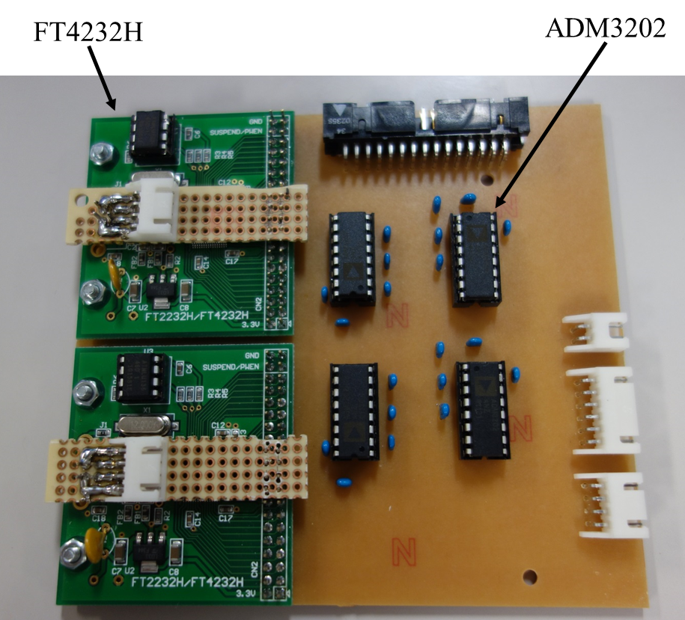
Fig. 7. Communication Unit

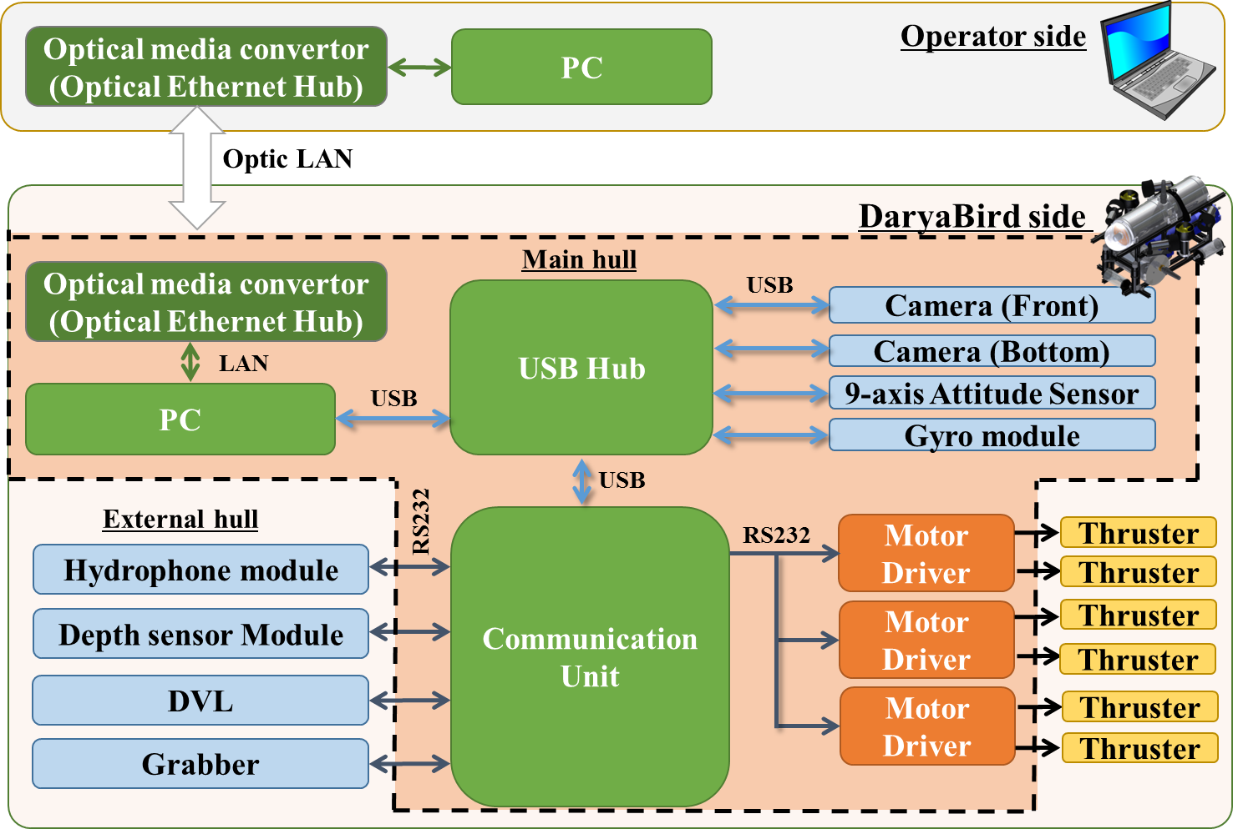
Fig. 8. system architecture of DaryaBird

Software System and Mission Strategy
Darya Bird’s software consists of three main layers as shown in Fig. 9. Decision making is done in the upper layer called mission controller based on the information from sensors. Motor control command values are generated in this level and send to the middle layer. For example, the top layer is responsible for image processing during buoy-touch and the behavioral transition of searching and approaching. The middle layer calculates thruster power output based on the command values from mission control layer. Surge and sway motion is performed by feedforward PID speed controller shown in Fig. 10. For controlling heave and yaw, P-PI controller shown in Fig. 11 is used which leads to control the depth and heading angle of the robot. The lower layer takes care of the communication between each devices mounted on the AUV.
Serial communication devices such as motor drivers and DVL and image acquisition device such as USB camera communication is made in this layer. The software configuration can be switched for simulation.
MATLAB/Simulink is adopted for its excellent legibility to speed up the development efficiency.
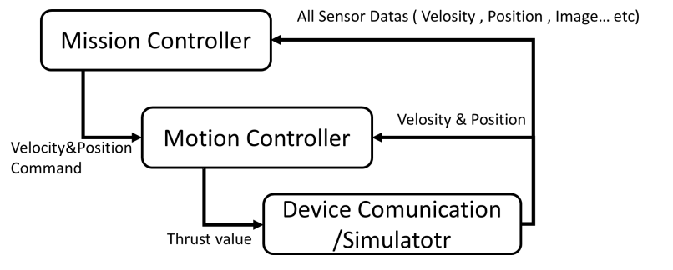
Fig. 9. Software layers

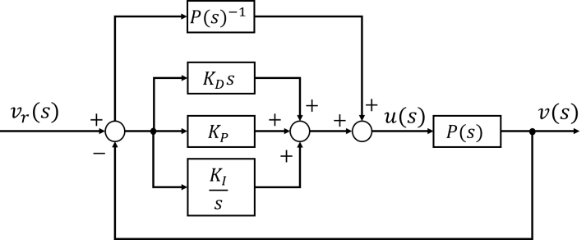
Fig.10 Velocity control system (Surge & Sway)

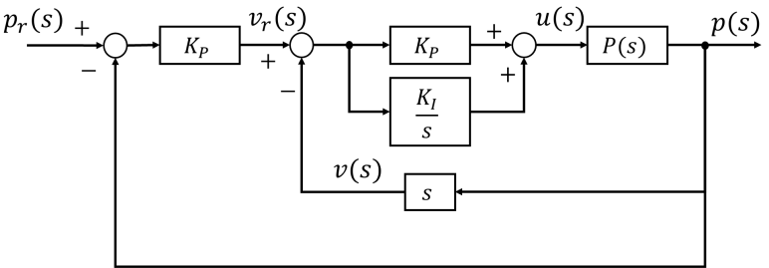
Fig. 11. Positon/Angle Control system (Heave & Yaw)

The configuration of the software
Controlling system, Motion Control, Device Communication and Simulator are developed in MATLAB/ Simulink environment. State flow in Simulink is basically used in this modelling. Each mission is described independently in state flow and at the end of mission, specified the next mission. We can easily remodel the mission strategy by changing specifying the next mission.
Fig. 12 shows the flowchart of the mission. In last year, we cleared ‘Gate’ and ‘Buoy’. In this year, we have planned to achieve the mission of ‘Gate’, ‘Path Marker’, ‘Buoy’, ‘Navigate Channel’ and ‘Bury Treasure’.
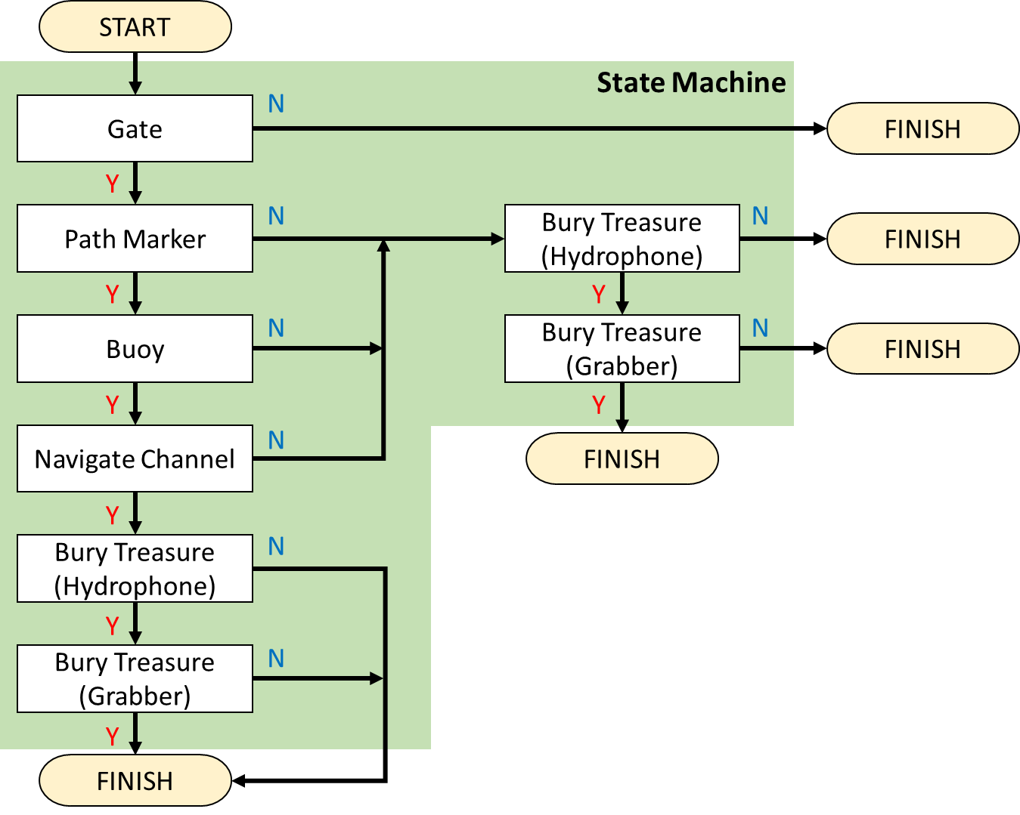
Fig. 12 Over view flowchart of mission

Image Processing
Our image processing framework consists of color thresholding, moment detection, edge detection techniques. Preprocess of the image processing is combining YUV and HSV in color space. This process is insensitivity to change by combining color space. This process is employed commonly in underwater robotic applications because it is a special environment differ from the normal on ground environment. Underwater robot can’t recognize many color in this method, but image processing has ability for recognizing only the yellow and red, that would be enough for the mission. Result of the object recognition system based on the image processing is given in Fig. 13, which describe the identification of the red ball properly.
Binarization Image
Original Image
Fig. 13. source-image and red extraction

Path Marker
This mission take visual feedback. At first, extract guide color. Next, get the angle. Robot heading control that angle value to target value. And, robot move to center of guide’s moment position.

Buoy
Detect buoy moment in water. At first, aim the center of buoy by using heave thrust and sway thrust. And, do the behavior. At this time, detect buoy distance.

Bury Treasure (Hydrophone)
Robot don’t move thruster when using a hydrophone. This year our team put a lot of work into that capture of acoustic. We are two prepared that capture method of acoustic.
Firstly, calculate the angle by SSBL method. Secondly, estimate the orientation. When sound angle can’t know. Robot heading changing little by little for search an acoustic lighthouse. Then, Go to the acoustic lighthouse.

Bury Treasure (Grabber)
Reach the acoustic lighthouse afterward we’ll try gripper mission. Grab the object. And, surface in octagon.

Sensor system

Hydrophone System
Super-short-baseline (SSBL) is adopted for underwater acoustic detection device. This scheme is intended to use a hydrophone array with the hydrophones in small distance. Fig. 14 shows outline of SSBL method. The arrival angle of the sound source is predicted from calculation of the phase difference between the hydrophones. In SSBL method, arrival angle $θ_{xy}$ is described by the following equations. Here, $δϕ$ is phase difference [rad], $λ$ is wavelength [m], $d$ is installation interval of hydrophones [m].

$$θ_{x}=\cos^{-1}\left(\frac{{δϕ}_{x}}{π}∙\frac{\frac{λ}{2}}{d}\right),θ_{y}=\cos^{-1}\left(\frac{{δϕ}_{y}}{π}∙\frac{\frac{λ}{2}}{d}\right)$$ | (1)
$$R=\frac{z_{t}}{\sqrt{1-\cos^{2}{θ_{x}-\cos^{2}{θ_{y}}}}}$$ | (2)
$$x_{t}=R\cos{θ_{x}},y_{t}=R\cos{θ_{y}}$$ | (3)
$$θ_{xy}=\tan^{-1}{\frac{y_{t}}{x_{t}}}$$ | (4)

As shown in the Fig. 15, Team Kyutech’s Passive Sonar System uses electronic circuits for signal amplification, phase compactor and SH7125 as MPU. The phase comparator’s output signals are inputted to SH7125. SH7125 processes the phase difference information, and transmits the arrival angle to PC.
In this system, input signal voltages from the hydrophones need to be amplified the same level to compare the phase difference correctly. Therefore this system has an automatic amplitude adjustment function using Programmable Gain Amplifier (PGA). SH7125 observes the signal after the amplifier pass, and controls the PGA such that the maximum peak of amplitudes become equal to set voltage.
Fig. 16 shows actual Passive Sonar System module.

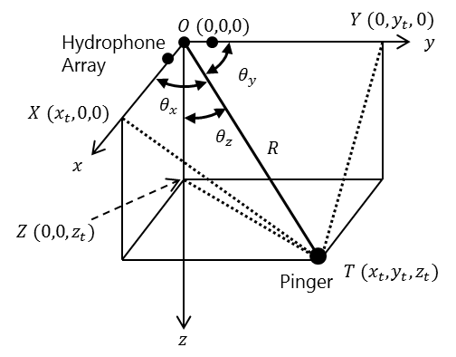
Fig. 14. SSBL acoustic positioning

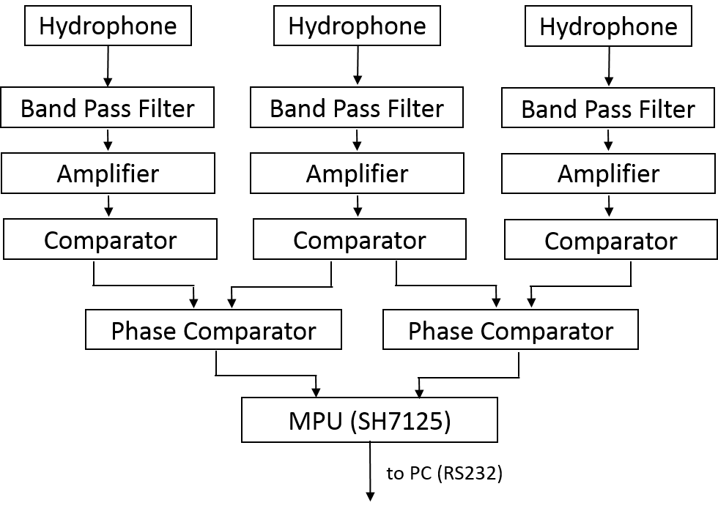
Fig. 15. Passive sonar system

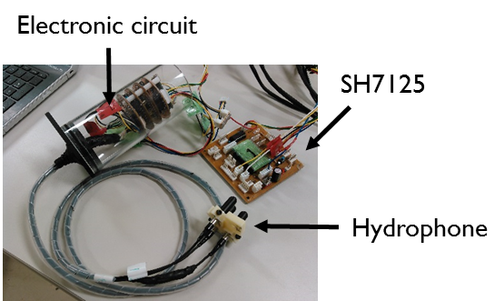
Fig. 16. Passive sonar system module

Altitude sensor
As attitude sensor, ’TRAX’ made by PNI Sensor Corporation is installed for the control of motion in main hull. The TRAX is able to measure rolling, pitching and yawing motions. Acquisitioned data are transmitted through RS 232.
In addition, Gyro module is installed in main hull. The angular velocity obtained gyro sensor (MPU-9250) is integrated by Arduino micro. The Gyro module is able to measure yawing motions. Yawing angle is not correct because MPU-9250 include some noise. As a countermeasure, it reduces the dispersed using a Kalman filter.

Experiment result

Hydrophone
We conducted experiment that control the amplitude of hydrophones. The set voltage is 3500[mV]. Also allowable power fluctuation range is from 3300 to 3700[mV]. Sound source was used tone burst signal and the frequency is 45[kHz], burst cycle is 2 [sec], burst time is 2 [msec].
Amplitude adjustment was applied to the first two milliseconds of the signal. Fig. 17 shows before adjustment signal. Fig. 18 shows result of automatic amplitude adjustment. In Fig. 17, the amplitude level is insufficient due to gain shortage. In Fig. 18, the maximum peek is adjusted to the set voltage. As a result, for the burst signal of 2 [msec], it was possible to adjust the peak within a target range.

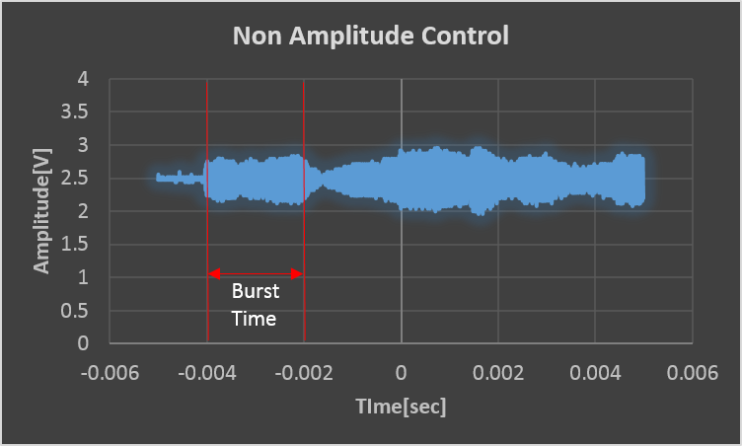
Fig. 17. Before adjustment signal

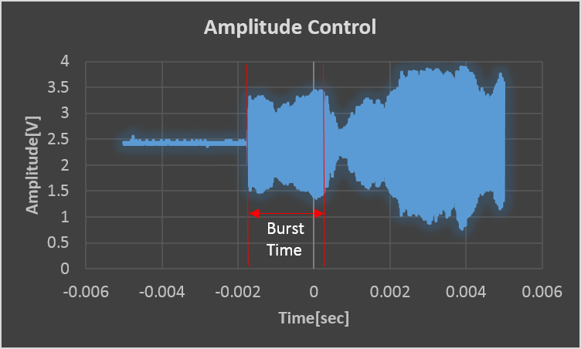
Fig. 18. Apply amplitude adjustment

Object distance estimation
To difficult. Robot get information current position. Therefore, we need measure distance to the object. Developed Object distance estimation algorism is simple. Buoy image process to extraction the color. Detected pixel area surrounding rectangle. And, distance calculated using rectangular area. Pixel area does not change by square surrounding pixel area
$$D2=\sqrt{\frac{S1}{S2}}・D1$$
S1: Initial area S2: Detection area
D1: Initial distance D2: Current distance

This process can measure the distance from DB-camera to object. If object change object size and simple shape that it is estimated distance. Even if measure distance that it change object size and simple shape. Necessary parameters, initial distance, object size and object-size parameter calculated in experiment. Therefore, we can measure the distance in different area by changing the size.
As a result. This process within 2.5 meter web camera to object in under water. But, now preprocess measurement to difficult detect object at least 3 meter in under water.
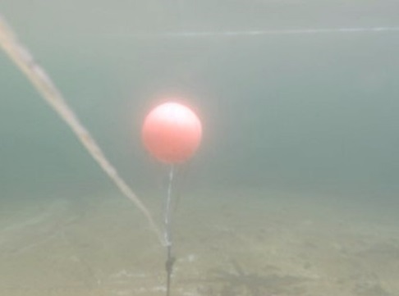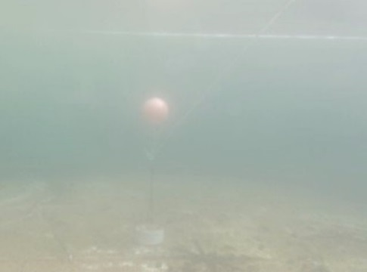
3m from the camera
1m from the camera
Fig. 19. Buoy visible from USB camera

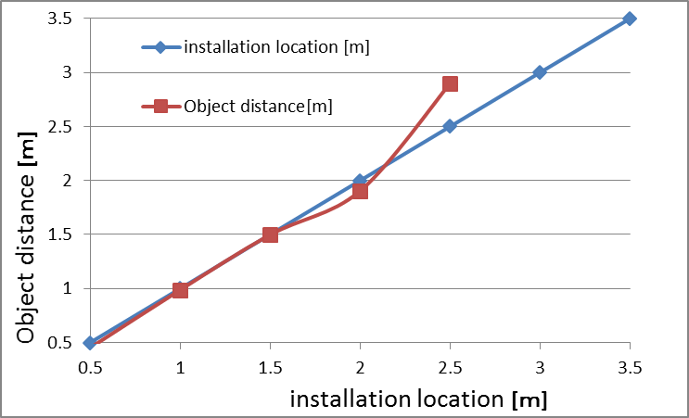
Fig. 20 Estimation result

reference
- T. Ura “Free Swimming Vehicle PTEROA for Deep Sea Survey.” Proc. of ROV’ 89, pp. 263-268, 1989
- K. Ishii, T. Fujii, T. Ura, “An On-line Adaptation Method in a Neural Network Based Control System for AUVs,” IEEE Journal of Oceanic Engineering, Vol. 20, No. 3, pp. 221-228, 1995.
- S. Nishida, K. Ishii, T. Furukawa, “An Adaptive Neural Network Control System using mnSOM,” CD-ROM Proc. of OCEANS ’06 Asia, 2006.
- K. Ishii, S. Nishida, T. Ura, “A Self-Organizing Map Based Navigation System for an Underwater Vehicle,” Proc. of ICRA’04, pp. 4466-4471, 2004
- M. Ishituka, S. Sagara, K. Ishii, ”Dynamics Analysis and Resolved Acceleration Control of an Autonomous Underwater Vehicle Equipped with a Manipulator,” Proc. of UT’04, pp.277-280, 2004
- Hidaka, Shota, et al. "System Design and Hardware Development of Autonomous Underwater Robot “DaryaBird”." AUVSI&ONR’ s 18th Annual RoboSub Competition Journal Paper (2015), July 20 - July 26, 2015 SSC Pacific TRANSDEC, San Diego, CA
- Official Rules and Mission, AUVSI Foundation & ONR’s 18th Annual RoboSub Competition, Space and Naval Warfare Systems Center, SSC SD TRANSDEC Facility, San Diego, CA, 2015.

